Software Requirements Specification For

Kalpani Oil Delivery

**Version 1.0**

Prepared by

Group Name:XOCODES

|  |  |  |
| --- | --- | --- |
| Nadeesha Gimhana | 941510272V | nadeesharb@gmail.com |
| Suhada Prasanna | 923560173V | suhadaprasanna@gmail.com |
| Sesath Dissanayake | 930923036V | [sesathdissanayake@gmail.com](mailto:sesathdissanayake@gmail.com) |
| Shanaka Sandaruwan | **930170771v** | shanakasandaruwan@gmail.com |
| Buddhika prasanna | **943293007v** | kbuddhika89@gmail.com |
| K.punnajee |  | k.punnajeehimi@gmail.com |

Table of Content

Contents

*1.4* Overview 6

1. Overall Description 6

2.1 Product Perspective 6

2.2 Product Functions 8

2.3 Operating Environment 9

2.4 User Characteristics 10

2.5 Assumptions and Dependencies 12

2.6 Apportioning of Requirements 12

2. Specific Requirements 13

3.1 Functional Requirements 13

3.2 Performance Requirements 14

3.3 Design Constraints 15

3.4 Software System Attributes 30

3.5 Modeling Requirements 33

3. Supporting Information 50

4.1 Appendixes 50

1. **Introduction**

SRS stands for System Requirement Specification. SRS is used by developers to implement the system; it also provides the complete behavior of the system. It is a comprehensive description of the intended purpose and environment for software under development.

The SRS fully describes what the software will do and how it will be expected to perform. An SRS minimizes the time and effort required by developers to achieve desired goals and also minimizes the development cost.

A good SRS defines how an application will interact with system hardware, other programs and human users in a wide variety of real-world situations. Parameters such as operating speed, response time, availability, portability, maintainability, footprint, security and speed of recovery from adverse events are evaluated.

The software requirement specification assures the project management stakeholders and clients that the development team has really understood the developing requirements documentation properly. This also provides confidence that the team will develop the functionality which has been detailed.

The SRS is documented in such a way that it breaks the deliverables into smaller components. The information is organized in such a way that the developers will not only understand the boundaries within which they need to work, but also what functionality needs to be developed and in what order.

These two points are particularly important in the process of software development. If your development team do not understand that there are certain constraints on their work, as for example the code must be tightly written so that it will compile and run quickly, then you will run into problems later on when the code might deliver the functionality required, but no one will ever see it because it takes so long to load.

Understanding what order the functionality will be developed in means that the developers have the "big picture" view of the development. This gives them an opportunity to plan ahead which saves both project time and cost.

* 1. Purpose

They are currently using paper-based system. The head office or the authority wants to know about various goods of products or raw materials of store every now and then and about the deliveries, they make every day. The store department often fails to produce instant required report as it is paper based and that causes various obstacles. Reporting or any query becomes a lengthy process, which is undesired for a reported industry.

Generally, a Coconut Oil Production and Delivery System means a system that comes under some systematic and defined protocols with some sequential rules and regulations, data storage with convenient searching and retrieval, a clear interaction between the subsystems all of which are strictly maintained by computer software and hardware. The main purpose of a kalpani Oil Delivery System is to collect the production and store information for all materials in that Industry in an efficient and effective manner, so that information can be stored, processed and collected with ease as required.

* 1. Scope

1. Kalpani Oil Delivery System
2. We handle in our application…
   * Stock Management
   * Self-Product Management
   * Employee Management(Register, Attendance, Salary)
   * Cash Book and Check Book
   * Product Delivery management(Delivery vehicle, Routes)
   * Supplier Info
   * Customer Info
   * Invoice
   * Reduce huge man power
   * Reduce the possibility of goods, parts, raw materials, product losses.
   * Manage stock query quickly
   * Reporting timely to authority become possible

We do not handle…

* Manual Processes
* Provide online data

1. Benefits
   * Efficient service provider.
   * Easy implementation
   * User friendly for data retrieval, update, and deletion
   * Easy learning environment for employees

Goal - The ultimate goal of the project is to fully computerized the current garment factory management system.

Objectives – These objectives are divided into 2 parts

* + - The functional objectives
    - The technical objectives

**Functional Objectives**

The functional objectives are

* To provide information in minimum time and with minimum effort.
* Try to avoid human committed errors and misclassification as far as possible.
* Try to offer better services in comparison with the services offered by the present system.
* To make the whole process error free, reliable and fast.
* To ensure the avoidance of the duplication of the various process.
* To build up a fully multi user system.

**Technical objectives:**

The technical objectives are additional to user’s performance and functional objectives. These needs influence design decision and the cost benefit trade of decision that should strongly be considered by the numbers of project term during the design stage of the project. The technical objectives considered in this project are as follows:

* To design the project with the flexibility so that it can be changed in future and thus making an extension of the expected life of the system.
* To make the system easily maintainable so that the workers and users of the system can handle the system satisfactorily with easy and convenience.
* To schedule the project efficiently so that the administration can provide the cost systematically and the time used for the development of the system should not take too long unnecessarily.
* To design the system smartly and efficiently so that it can become an ideal system for the purpose of use and study.
* To build the system with security consideration for mainly the administration part of the system.
* To ensure the reliability of this system i.e. the hardware or software failure, action can be taken. So necessary software backup should be taken safely.
* To made the design simple as far as possible since the se based computerized multi user system is being considered for the first time and the simplicity will be very helpful for untrained users and operators of the system.

1.3 Definitions

SRS – System Requirement Specification

BRS – Business Requirement Specification

FRS – Functional Requirement Specification

GRN – Good Receive Note

Invoice – A details discretion of good or services that the customer purchased. Invoice includes the total, net amount, discount, subtotal and amount paid

## Overview

Only one kind of user is controlling the system (Admin). To access the system user must have the proper authentication. Administrator is the super user who will have the power to add, update, and delete different kinds of information about product or any other information.

# Overall Description

## Product Perspective

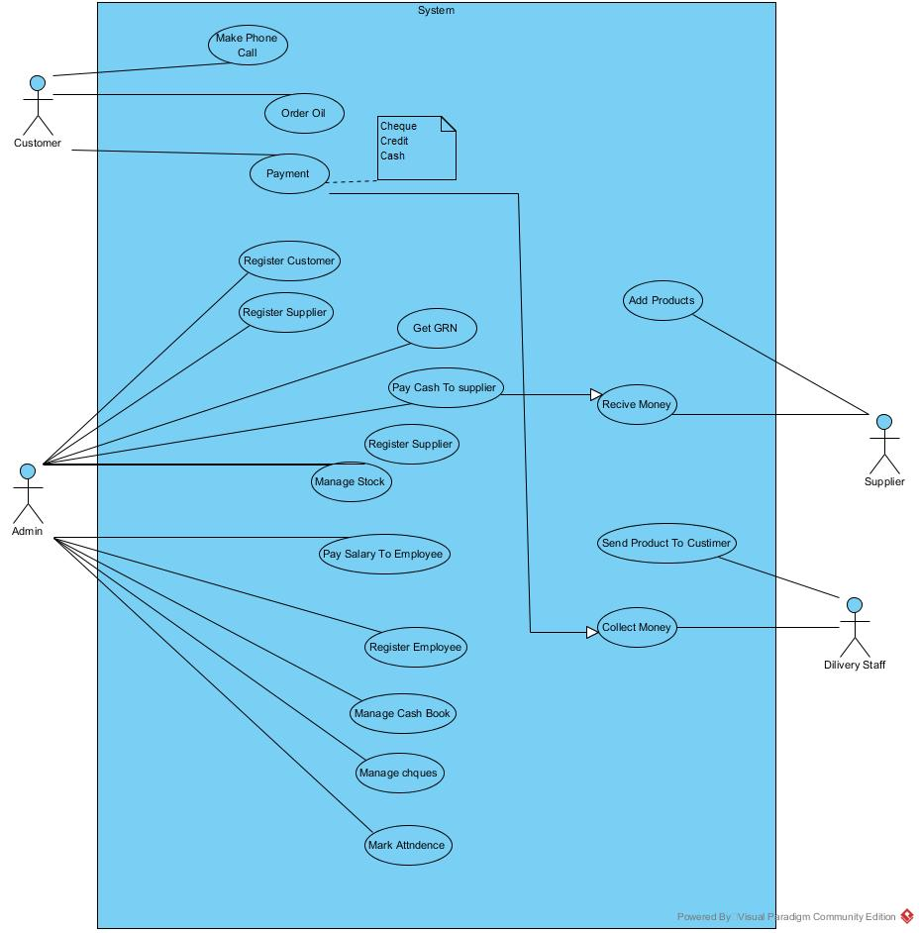

**Pre-Condition:**

Only coconut oil and its products are managed from the system. Production can only be started if the required raw materials are available

A supplier will only bring one product at a time

Only one vehicle will travel in one route at a time.

**Post Condition:**

Generate different report for various requirements

## Product Functions

* + 1. ER Diagram

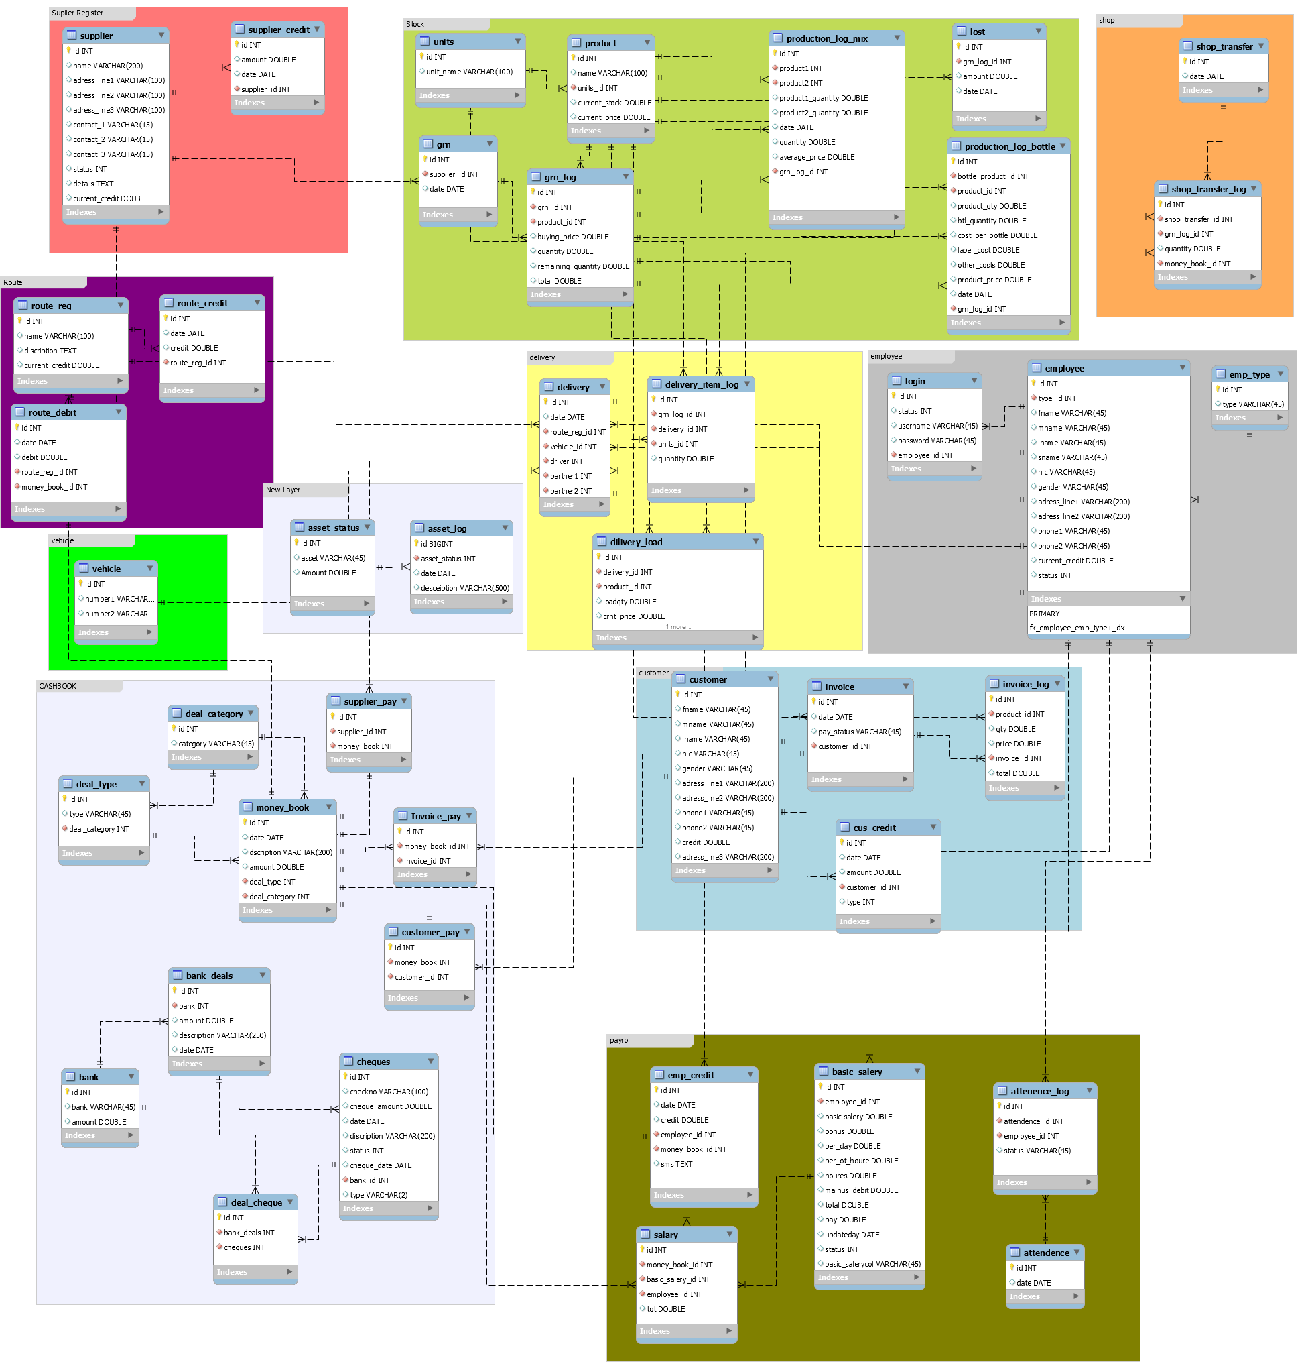

we discuss about our proposed system. Kalpani Oil Delivery Systemis a very important area where all product and delivery information is kept. All the product, agent, administrator and buyer information are stored into this system. The proposed system should have the following facilities to serve the better service:

## Operating Environment

This Management System will compatible with all operating systems like, windows, mac operating system and also works fine with Linux operating systems. We require some conditions in advance like,

* In windows we require 1GB of memory, 6GB hard disk space to run this system for the minimum.
* In Macintosh we require x 2.5 and 1GB of memory, 8GB hard disk space to run this system for the minimum.
* In Linux we require 1GB of memory, 6GB hard disk space to run this system for the minimum.

The System has Graphical User Interfaces. The Product Owners of XOCODES Software will expect their programmers to be able to iterate much faster, since the installation base is much smaller and well-known. There are fewer environment permutations to consider

(e.g. you may know up front that the software should only have to be able to run on Windows Server 2008 R2 with a SQL Server 2008 R2 database.)

The entire deployment environment is also well-known, so there are many assumptions you can trust to hold. This indicates that you should be able to produce software in an 'agile' manner. Because the Zoo is a much less dangerous place, the software can be less robust (at least along some axes), which again indicates that it can be produced by a smaller team than corresponding Wildlife Software. This again helps keeping down cost.

## User Characteristics

There is only one type of user. The proposed system should have the following facilities to serve the better service:

* Admin has the privileges for the following activates.
  + Add stock
    - Add Stock
    - Shop
    - Lost Manage
    - Add Product
    - Add Units
    - Good Receiving Note Reports
    - Supplier Credit Pay
  + Self-Product
    - Add Product Mix
    - Add Product Bottle
  + Employee
    - Register Employee
    - Attendance
    - Credit
    - Salary Payment
    - Salary Temporary
  + Cash / Check Book
    - Summary
    - Cash Book
    - Check Book
    - Deal Logs
    - Setup
  + Delivery
    - Delivery Vehicle
    - Self-Products
    - Delivery Invoice
    - Vehicle Return
    - Vehicle Register
    - Route Register
    - Route Debit
    - Delivery Report
  + Supplier
    - Supplier Register
    - Supplier Status
  + Customer
    - Customer Registration
    - Customer Credit Manage
  + Invoice

**Benefit of The Users of the Proposed System**

In this section, we discussed thoroughly the benefits of different kinds of users. The users will get the faster system than the present system.

**Benefit of the Administrator**

The administrator will get the maximum benefit from it. Actually, this system is made for helping the administrator. He can see the all product information in any time. For that relevant category, he can take any decision easily and quickly. He can save lots of time by this system. He can utilize their time to other jobs. Using this system, we also reduce the physical labor of the administrator.

**Benefit of the Employee**

The agents also get the benefit from it. This system reduces the paper work and the physical labor of the agent.

Characteristic of system

Boundary – Factory

Inputs – Details of stock/ Progress Data

Outputs – GRN Reports, Invoice Reports, Pay sheet Report, Shop Transfer Log Report

Components – Admin

Interface – Production Progress/ Delivery/ Stock/ Cash/ Check Book

Environment – Delivery Placement / Production of Mixed Product

Process – Efficient Production of Oil Delivery System

## Assumptions and Dependencies

The assumptions are -

* The coding should be error free.
* The system should be user-friendly so that it is easy to use for users.
* The information of all users, customers and suppliers must be stored in a database.
* The system should have more storage capacity and provide fast access to the database.
* The system should provide search facility and support quick transaction.
* The system is running 12 hours a day.
* Users may access from any computer that has internet browsing capabilities and an internet connection.
* Users must have their correct username and passwords to enter into their accounts and do actions.

The dependencies: -

* The specific hardware and software due to which the product will be run
* On the basis of listing requirement and specification the project will be developed and run.
* The end users(admin) should have proper understanding of the product.
* The system should have the general report store.
* The information of all the users must be stored in a database that is accessible by the garment management system.
* Any update regarding the order placement to complete order is to be recorded to the database and the data entered should be correct

**Limitation: -**

* The active user may not have the proper IT knowledge to work on the system

## Apportioning of Requirements

**Suggested for Future Work**:

There are further more areas where the application can be developed to support the Factory. For example, HR system and Accounts system can be developed and integrated with this application to get the better outcome. Different reports can be designed to retrieve data from the database as per the requirements. The requirements of the management changes over the time. So the application also need to upgrade every after certain time. The server side validation was not performed in this application which is mandatory in good programming practice.

# Specific Requirements

## Functional Requirements

* Display the status of the ongoing activities.
* Supplier Credit Mange
* Customer Registration
* Customer Credit Management
* Product Registration
* Delivery Management
* Invoice Management
* Sales and Reports
* Stock Management
* Employee Management.

Hardware Interfaces

We used a Mobile Internet dongle to send the messages to each employees.

Software Interfaces

Windows Operating System.

JAVA Runtime Environment.

MySQL Database Server

Java swing

Java Hibernate.

We used the above mentioned interfaces to complete the development of the project.

Software will run on windows environment with JAVA running.

Communications Interfaces

Mobile Internet Dongle was connected to the software using COM port 13 for the functioning of the software.

Functional Requirements

Functional requirements should include functions performed by specific screens, outlines of work-flows performed by the system, and other business or compliance requirements the system must meet. Download an example functional requirements specification or use these quick examples below.

Interface requirements

* Field 1 accepts numeric data entry.
* Field 2 only accepts dates before the current date.
* Screen 1 can print on-screen data to the printer.

Business Requirements

* Data must be entered before a request can be approved.
* Clicking the Approve button moves the request to the Approval Workflow.
* All personnel using the system will be trained according to internal SOP AA-101.

Regulatory/Compliance Requirements

* The database will have a functional audit trail.
* The system will limit access to authorized users.
* The spreadsheet can secure data with electronic signatures.

Security Requirements

* Members of the Data Entry group can enter requests but cannot approve or delete requests.
* Members of the Managers group can enter or approve a request but cannot delete requests.
* Members of the Administrators group cannot enter or approve requests but can delete requests.

Depending on the system being described, different categories of requirements are appropriate. System Owners, Key End-Users, Developers, Engineers, and Quality Assurance should all participate in the requirement gathering process, as appropriate to the system.

Requirements outlined in the Functional Requirements Specification are usually tested in the Operational Qualification.

## Performance Requirements

Response Time:

The system shall give responses in 1 second after checking the patient’s information.

Capacity:

The System must support 1000 people at a time.

User-interface:

The user-interface screen shall respond within 5 seconds.

Conformity:

The systems must conform to the Microsoft Accessibility guidelines

## Design Constraints

* + 1. Report Format

Bank Deal Summary

* After we supply Bank Name it will produce us a report about the deals between the given Bank.
* Report was produce to overcome the trouble of viewing information about bank transaction

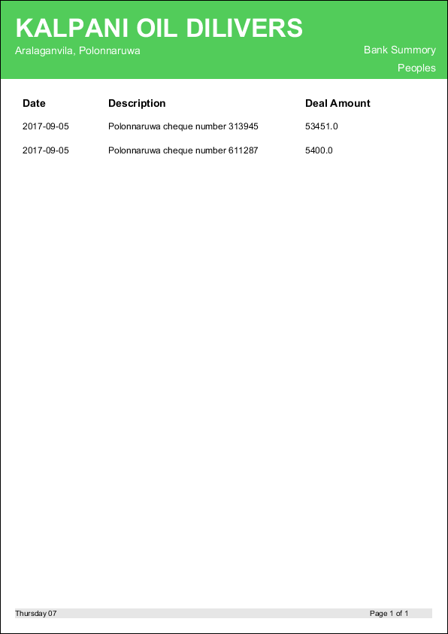

Bank Deal Summary According to Date Range

* After we supply Bank Name and Date Range it will produce us a report about the deals between the given date range on the selected Bank.
* Report was produce to overcome the trouble of viewing information about bank transaction in a given date period.

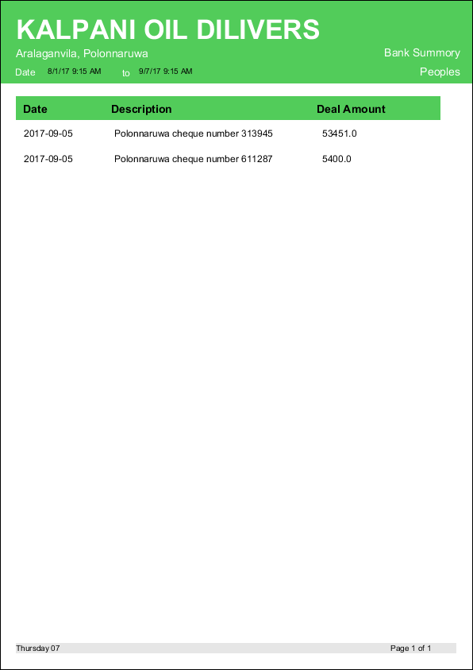

Bank Summary

Display information about current Bank totals

To overcome the trouble of looking through the records for current bank ammount

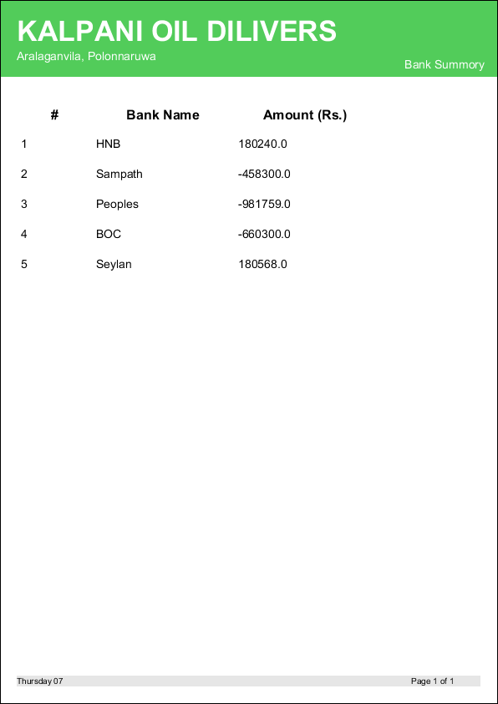

Pending Checks Pay Checks

Display information about pending pay checks

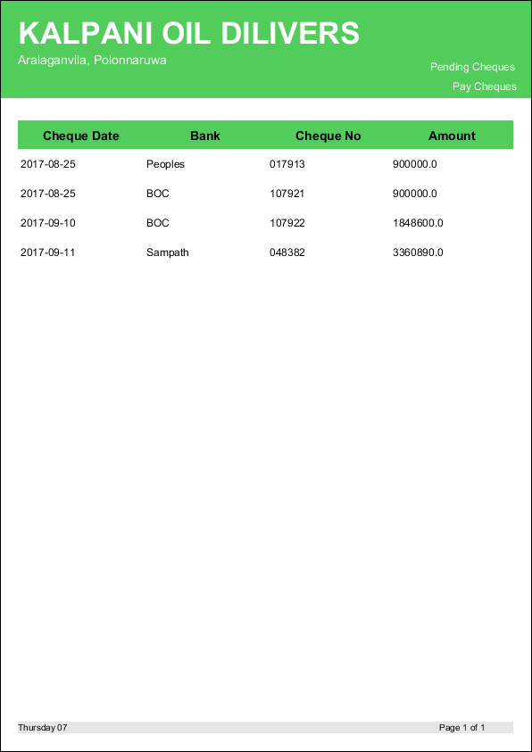

Pending Checks Receive Checks

Display information about all the checks that are on pending state which are to be received.

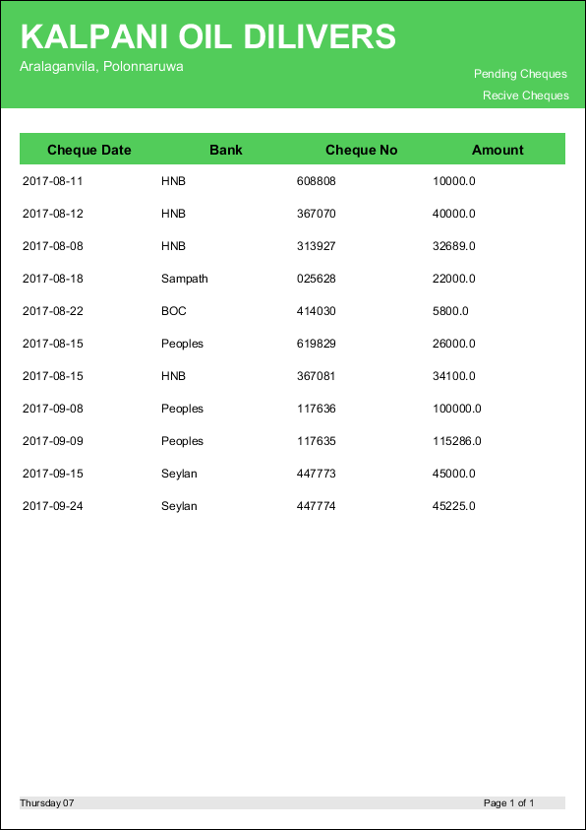

Deal Checks Receive Checks

Information about fully transitioned checks.

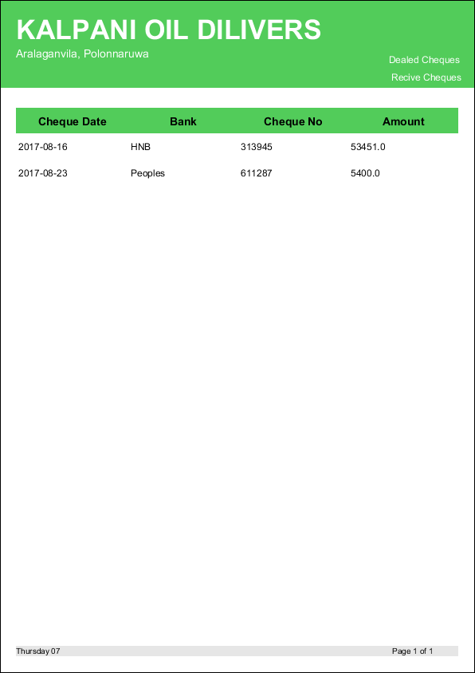

Deal Checks Pay Checks

Information about fully transitioned checks which were payed.

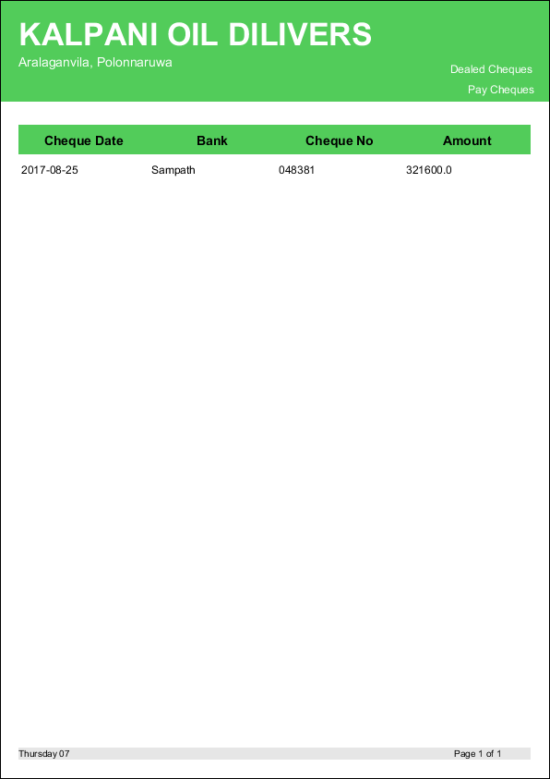

Money Book

Information about all money transactions within a given date range.

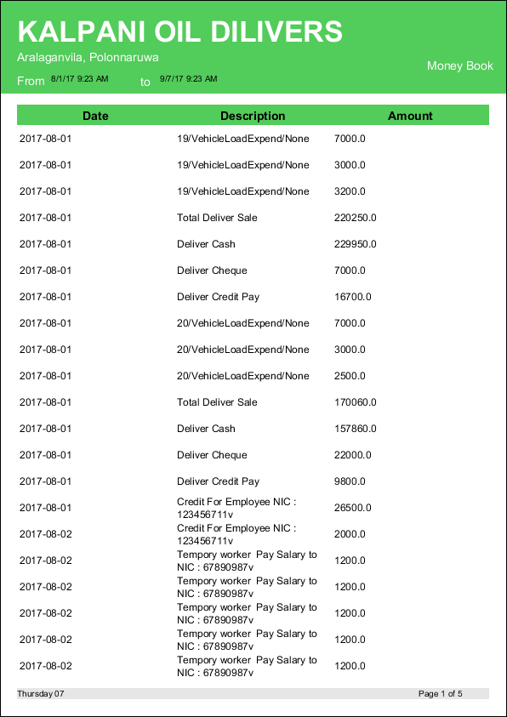

Money Book Income

All income transaction information within a given date range.

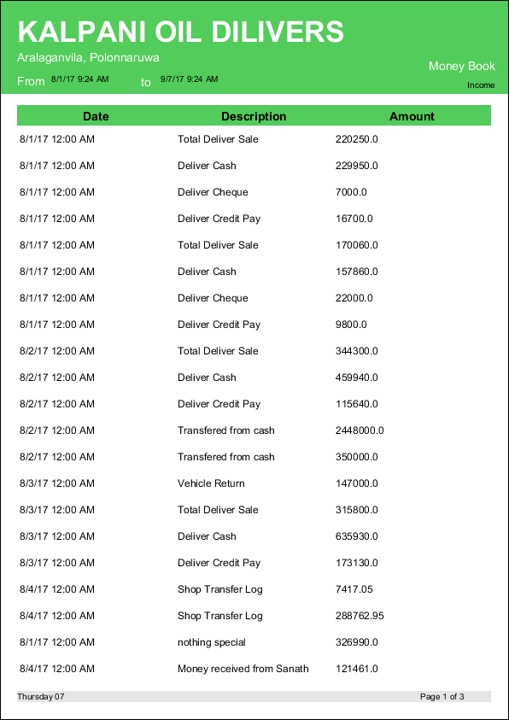

Money Book Expend

Display all expenditure information within a given date range.

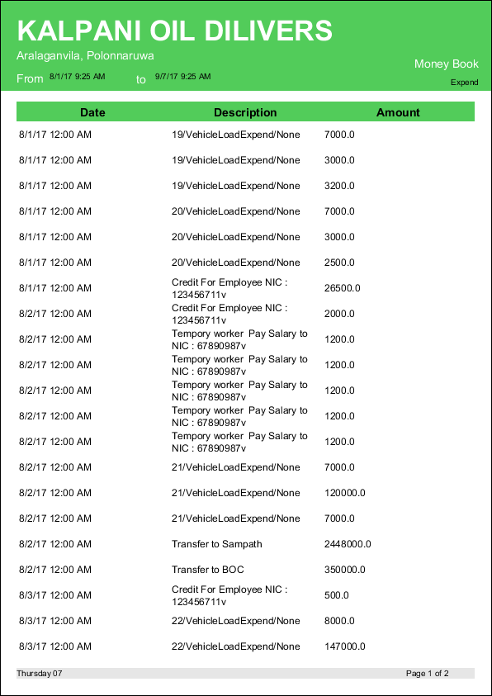

Money Book Delivery Cash

Information according to the deal type within a given date range.

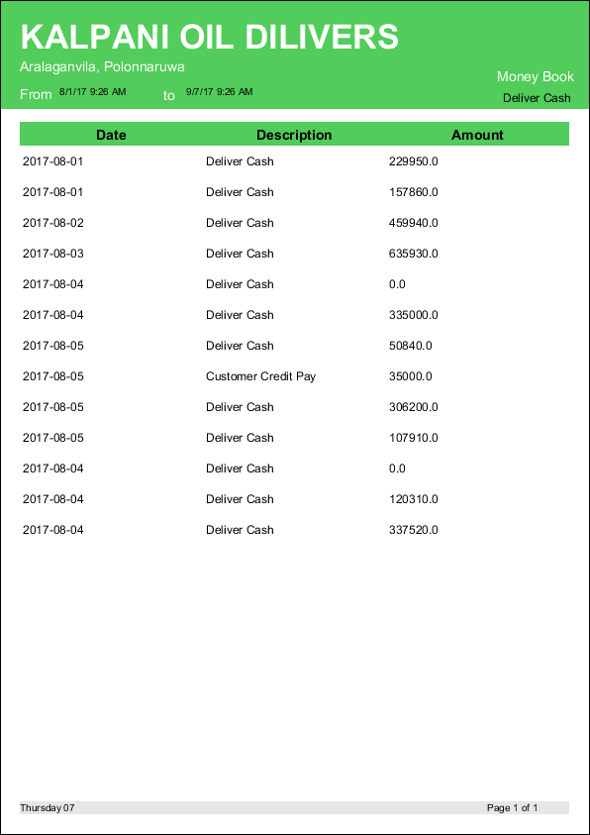

Invoice

Information about item purchase, which contain product name, quantity, price and total.

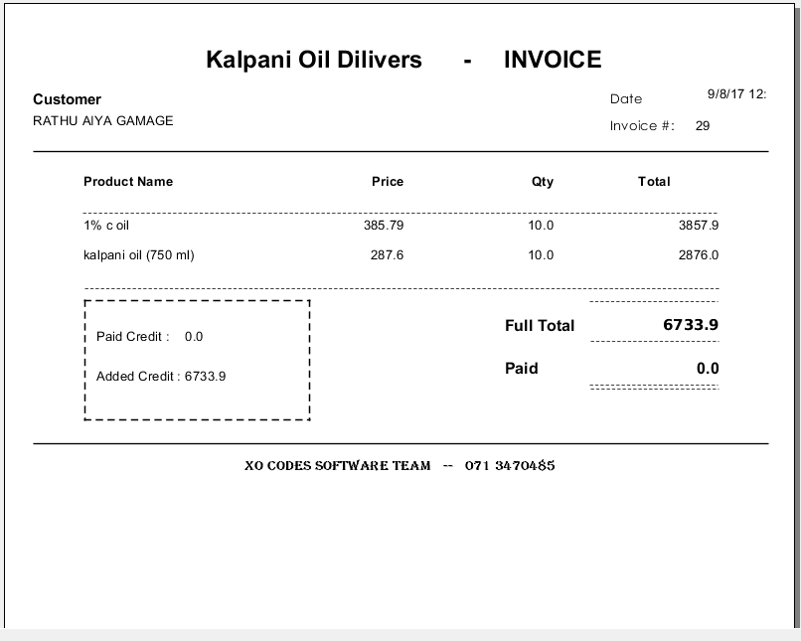

Employee Pay sheet

Display information about employee pay slip, which contain basic, bonus, OT hours

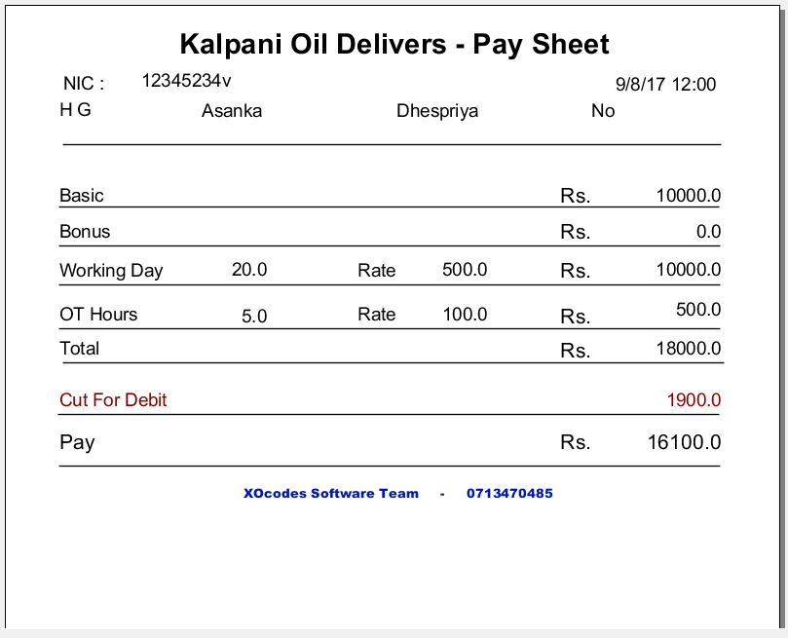

Good Receive Note

Information about product purchase summary given to the supplier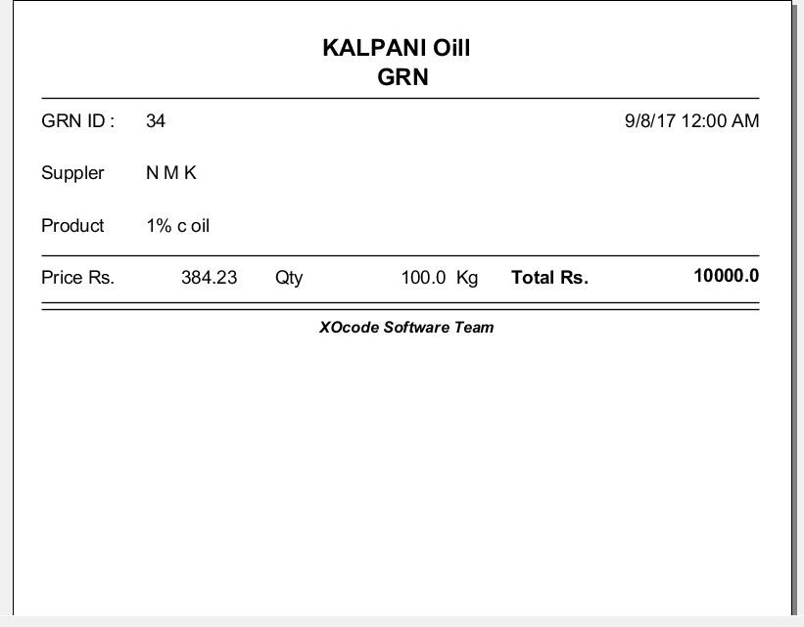

* + 1. Data Naming

Physical data element names embody the syntax and structure of data elements that are implemented in a technical environment. These physical data element names should be identical to the logical data element names to which they correspond; however, the technical constraints of the physical implementation may constrain their length and format. Should the technical constraints for a system development project make it impossible to adhere to these naming requirements. Accordingly, the semantic and syntactical rules that apply to logical names are consistent for physical data element names; however, the lexical rules accommodate the physical environment. Therefore, physical data element names shall comply with the following lexical rules:

* Nouns are used in singular form; verbs, if any, are in the present tense.
* Alphabetic and numeric characters are allowed; no special characters shall be accepted, except those hyphens and underscores that delimit the components of the data element name.

The use of numbers in the data element name shall be restricted and will only be accepted when the deletion of the number alters the meaning of the data element name. Also, the use of numbers in the data element name shall not be for the purpose of sorting.

* All words may be separated by either hyphens or underscores; spaces are not allowed. The delimiter selected should be used consistently within the context defined.
* All words may be in either mixed case, i.e., led with upper-case letters, followed by lower-case letters, or all capital letters.
  + 1. Accounting Procedures

The accounting principles of (Client X) will be consistent with all applicable laws. These include: Generally Accepted Accounting Principles, Statements of Financial Accounting Standards Numbers 93, 116 and 117, SOP 87-2 on Joint Costs, SOP 94-2 on the applicability of the accounting rules to nonprofits, and SOP 98-3 on accounting for federal awards.

* + 1. Audit Tracing

The accounting records and systems for funds must provide a clear **audit tracing** that makes it possible to trace all federal cash from drawdown to its final destination an **audit tracing**, whether in a manual system, an automated system, or a combination of systems, includes the accounting record of a transaction and all the documentation that supports each transaction. In accounting records, when data is recorded, a reference should also be recorded to identify the source of the data. The reference can be in the form of a date, a name, an address, or a number such as a journal page number, ledger account number, or check number. These references, used throughout the accounting cycle, form an **audit tracing** that makes it possible to trace the details of a transaction from the source document to the financial statements and accounting records.

* + 1. Hardware Limitations

This system has not online based system. Therefore, this system will be local network support only. So we can use limited hardware component for local area network connection.

## Software System Attributes

* + 1. Correctness

Every time inputs and outputs check the double time for most correct result return.

* + 1. Efficiency

We are require following system requirements to increase the efficient of system.

Windows 7/8/8.1 64bit/ Dual-Core Processor/ 2GB RAM/ 128VGA

* + 1. Flexibility

Database is also normalized to improve the flexibility of system.

* + 1. Integrity/Security

SQL injection is applying to this system to increase the integrity and security.

Only admin can access the database and create new user account.

* + 1. Interoperability

Required local area network

* + 1. Maintainability

Fix bugs and errors and add updates where system is located.

* + 1. Portability

Required the same environment.

* + 1. Reliability

We are looking for following operating system:

Upward Windows 7/ Linux OS /Ubuntu / Mac OS

* + 1. Reusability

We require for following operating system:

Upward Windows 7/ Linux OS /Ubuntu / Mac OS

* + 1. Testability

Provide various versions in this application.

* + 1. Usability

Give guidelines and training programs for new users/employees.

## Modeling Requirements

* + 1. Sequence Diagrams

Login Process

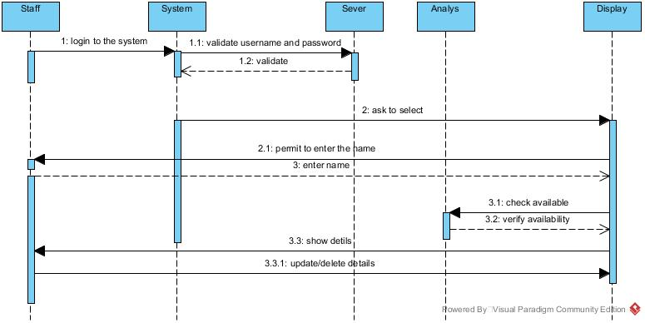

Monitor Details

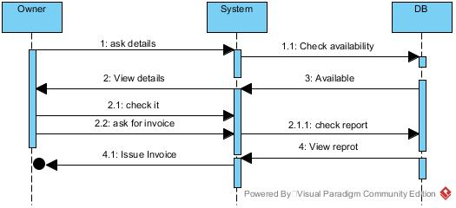

Return

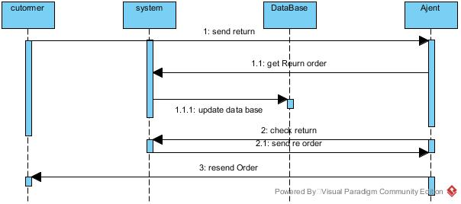

* + 1. Activity Diagrams

Login Process

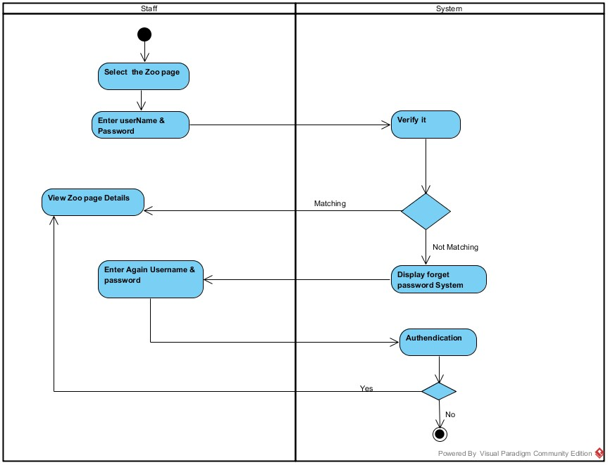

Employee Registration

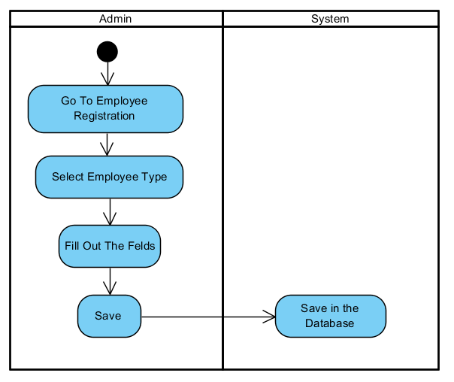

Attendance Mark

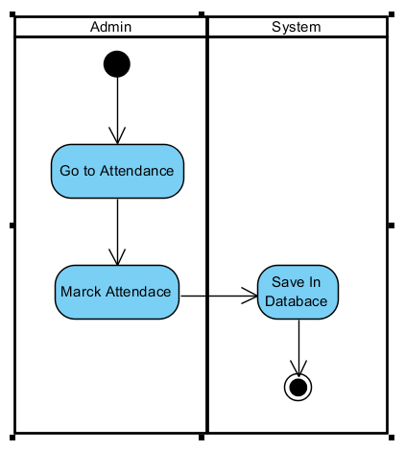

Employee Credit

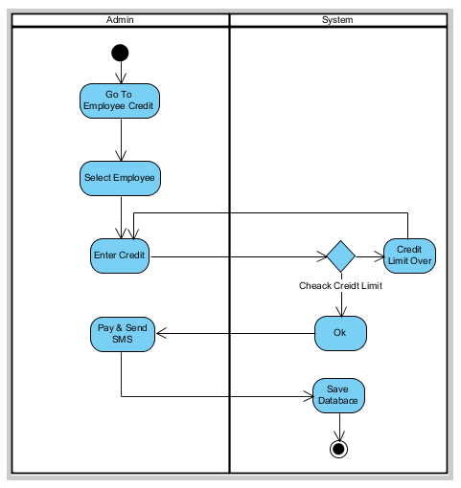

Monitor Details

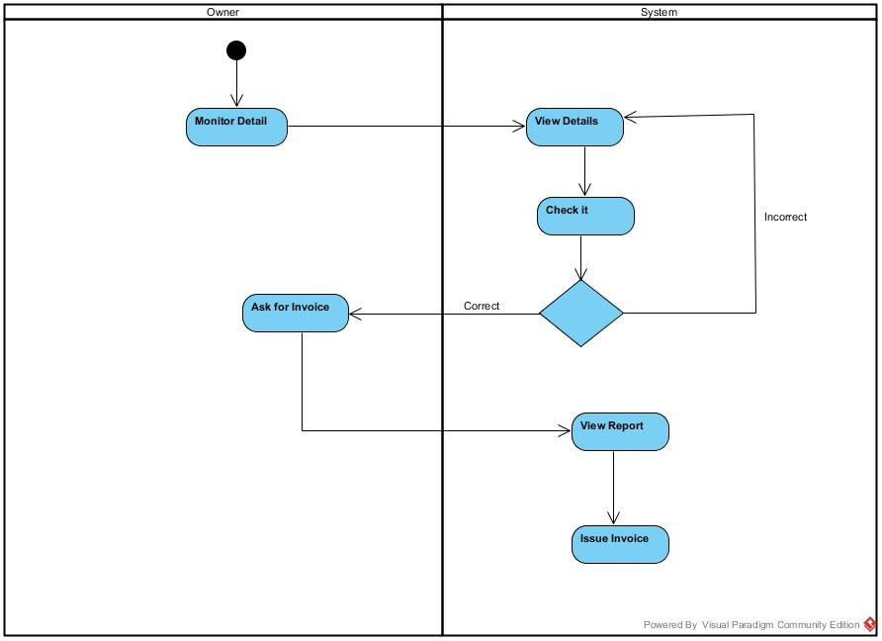

Class Diagram

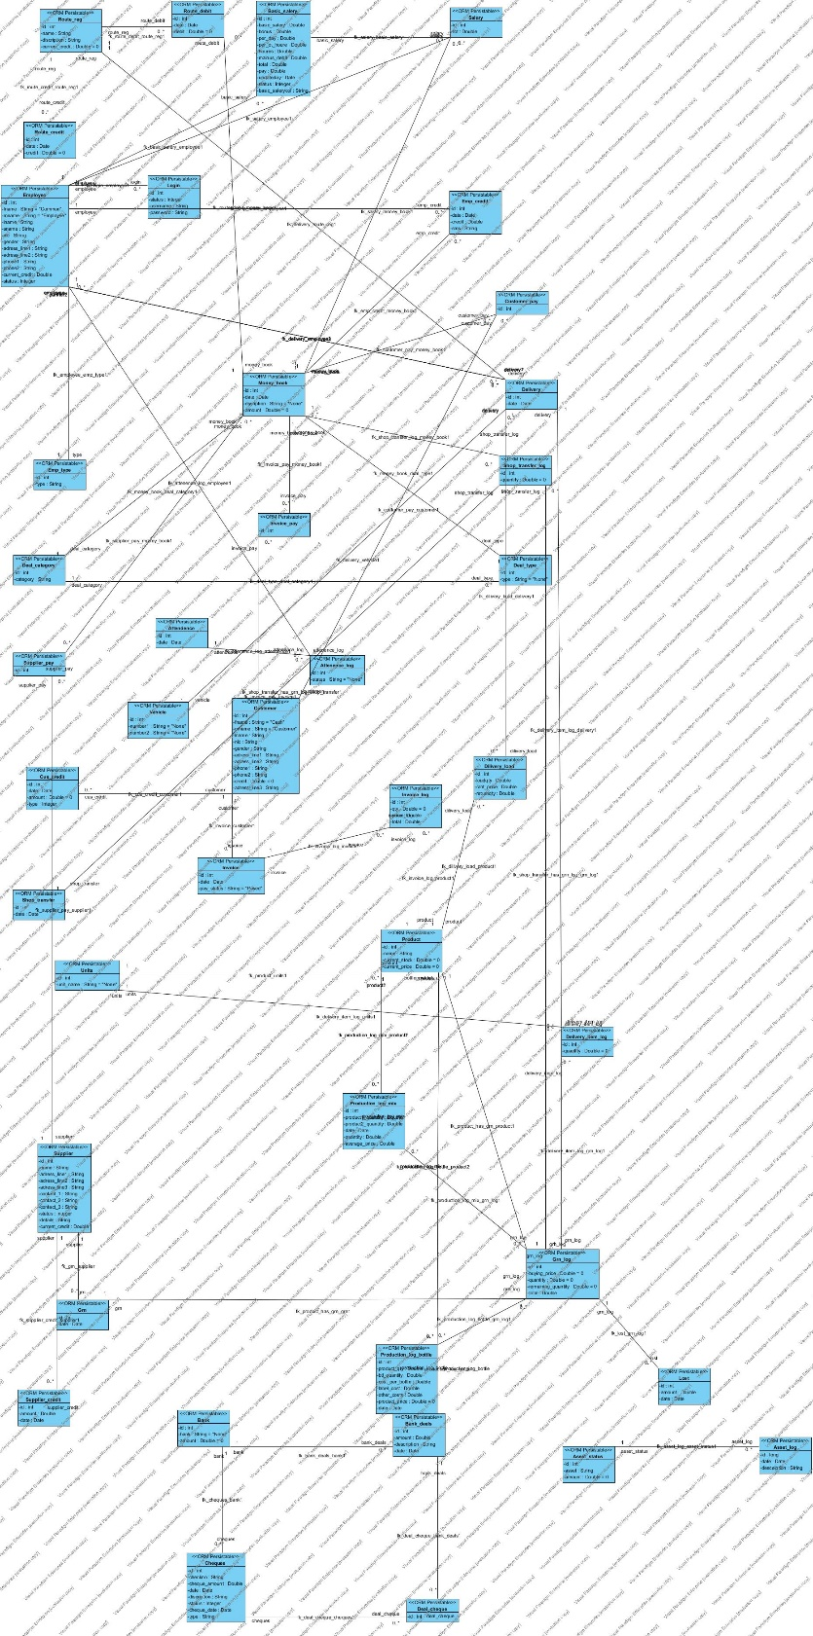

**Database Design and Data Table:**

For database design, first select database model. “Relational Data Model” has been selected. The relational model is today the primary data model for commercial data processing applications. It has attained its primary position because of its simplicity, which eases the jobs of the programmer as compared to earlier data model such as the network model or the hierarchical model.

In relational database structuring all data and relationships are representing in a flat, two-dimensional table called a relation. A relation database model has several features.

i)                    It allows the user to update the table, any position can be changed.

ii)                  It provides inquiry capabilities against a label.

iii)                Two or more tables can be merged to form one relation. Unlike hierarchical or network structuring where all relationship is predefined, a relation DBMS develops new relation on user commands.

**Database Name**

oildb

**List of Table**

oildb

customer_pay

invoice

production_log_mix

customer

delivery_item_log

asset_log

supplier_pay

shop_transfer

vehicle

deal_cheque

emp_type

grn_log

supplier

attendence

dilivery_load

money_book

basic_salery

employee

bank_deals

login

delivery

deal_category

grn

shop_transfer_log

route_reg

supplier_credit

salary

deal_type

units

route_debit

emp_credit

product

lost

attenence_log

bank

invoice_log

cus_credit

asset_status

invoice_pay

cheques

production_log_bottle

route_credit

**Description of Tables:**

supplier

id (int ai) :-

name (varchar) :-

address_line1 (varchar) :-

address_line2 (varchar) :-

address_line3 (varchar) :-

contact_1 (varchar) :-

contact_2 (varchar) :-

contact_3 (varchar) :-

status (int) :- “1” Inactive, “2” Active

unit

id (int ai) :-

name (varchar) :- “1” Killogram, ”2” Mililiter, “3” Bottel, “4” Half Bottle

grn

id (int ai) :-

supplier (FK) :-

date (date) :-

grnlog

id (int ai) :-

product (FK) :-

buying_price (double) :-

quantity (double) :-

remain_quantity (double) :-

grn (FK) :-

product

id (int ai) :-

name (varchar) :-

current_stock (double) :-

unit (FK) :-

shoptransfer

id (int ai) :-

date (date) :-

shoptransfer_log

id (int ai) :-

quantity (double) :-

grnlog_id (FK) :-

route

id (int ai) :-

name (varchar) :-

description (varchar) :-

current_credit (double) :-

vehicle

id (int ai) :-

number1 (varchar) :-

number2 (varchar) :-

delivery

id (int ai) :-

route (FK) :-

vehicle (FK) :-

date (date) :-

delivery_item_log

id (int ai) :-

delivery (FK) :-

grnlog (FK) :-

quantity (double) :-

employee

id (int ai) :-

fname (varchar) :-

mname (varchar) :-

lname (varchar) :-

sname (varchar) :-

nic (varchar) :-

gender (varchar) :-

contact_1 (varchar) :-

contact_2 (varchar) :-

address_line1 (varchar) :-

address_line2 (varchar) :-

address_line3 (varchar) :-

emp_type (FK) :-

status (int) :- “1” Deactive, “2” Active

emp_type

id (int ai) :-

type (varchar) :- “Admin”, ”Per”, ”Temp”, “Super Admin”

customer

id (int ai) :-

fname (varchar) :-

mname (varchar) :-

lname (varchar) :-

sname (varchar) :-

nic (varchar) :-

gender (varchar) :-

contact_1 (varchar) :-

contact_2 (varchar) :-

address_line1 (varchar) :-

address_line2 (varchar) :-

address_line3 (varchar) :-

status (int) :- “1” Deactive, “2” Active

bank

id (int ai) :-

name (varchar) :-

amount (double) :-

income_type

id (int ai) :-

type (varchar) :-

expenditure_type

id (in tai) :-

type (varchar) :-

salary_pay

id (int ai) :-

employee (FK) :-

expenditure

id (int ai) :-

date (date) :-

description (text) :-

amount (double) :-

expenditure_type (FK) :-

expenditure_check_details

id (int ai) :-

bank (FK) :-

check_number (varchar) :-

expenditure (FK) :-

income

id (int ai) :-

date (date) :-

description (text) :-

amount (double) :-

income_type (FK) :-

income_check_details

id (int ai) :-

bank (FK) :-

check_number (varchar) :-

income (FK) :-

# Supporting Information

## Appendixes

* + 1. GUI

**Home Page**

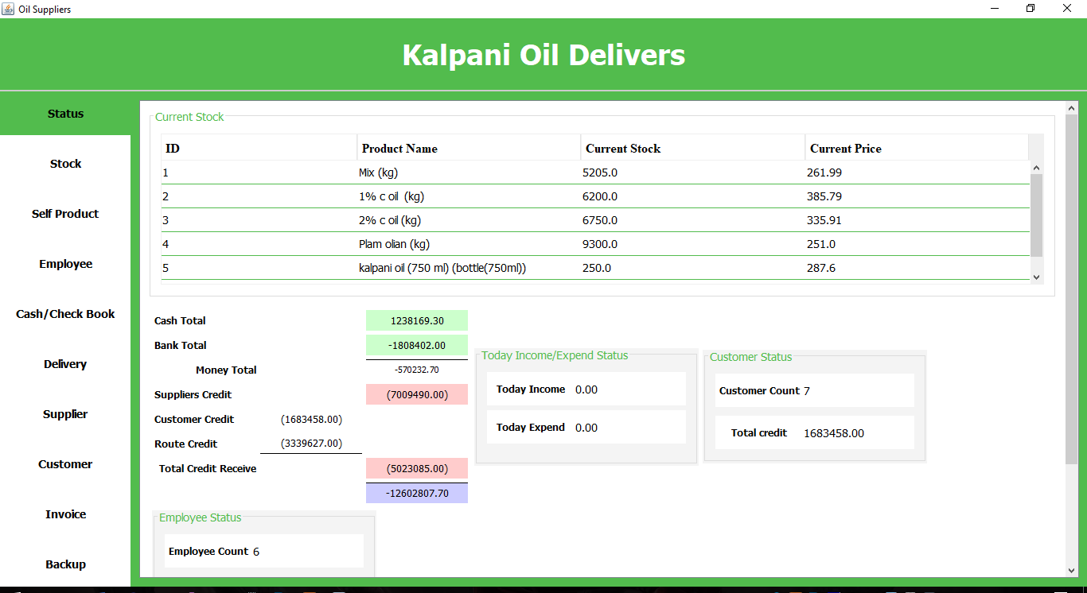

**Stock**

**Add stock**

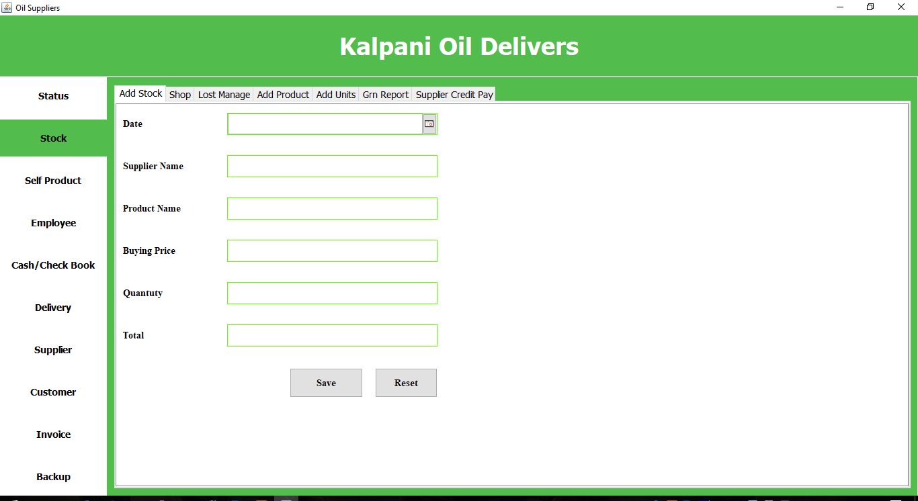

**Shop**

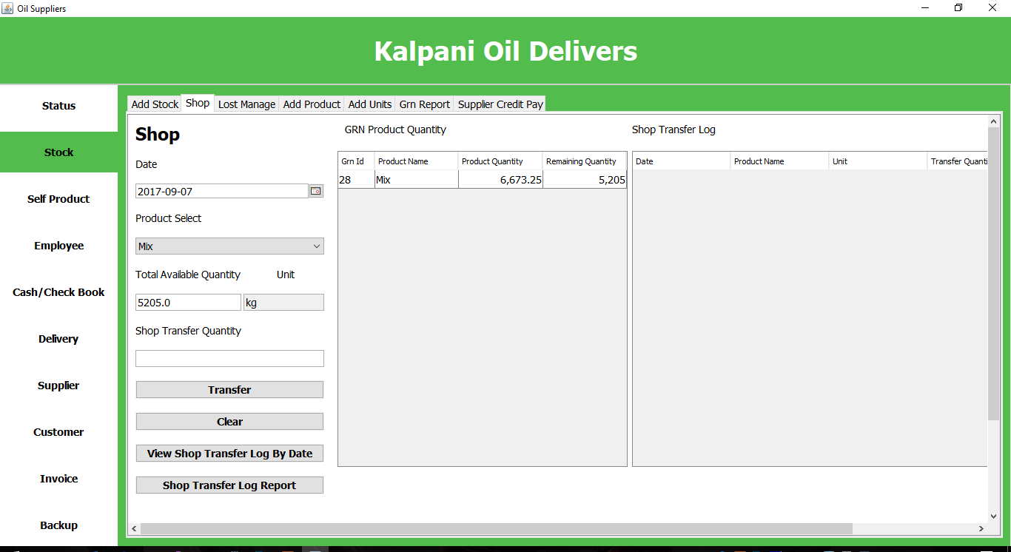

**Lost Manage**

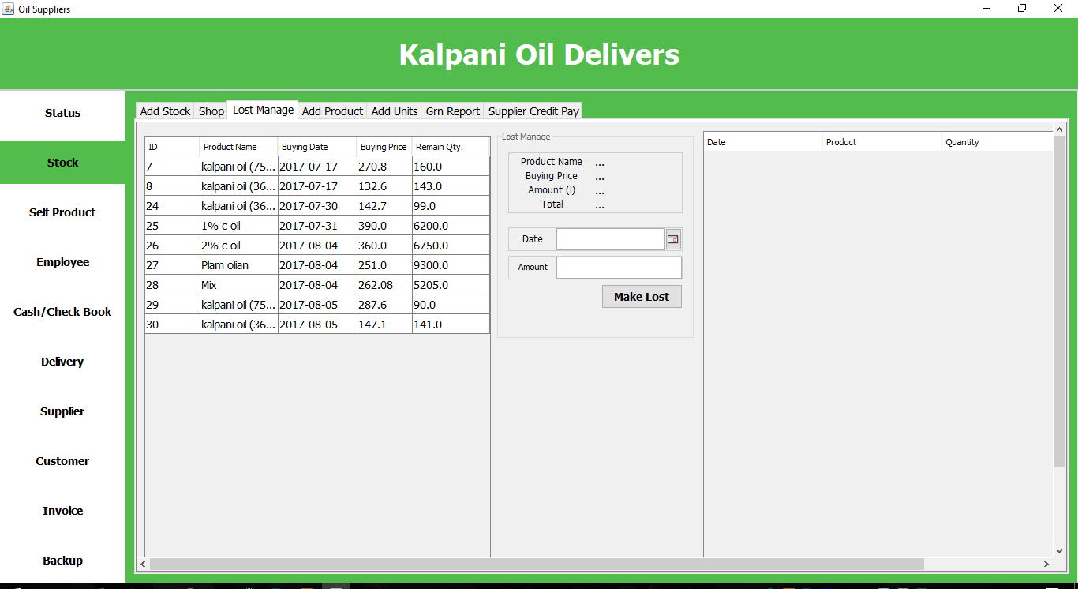

**Add Product**

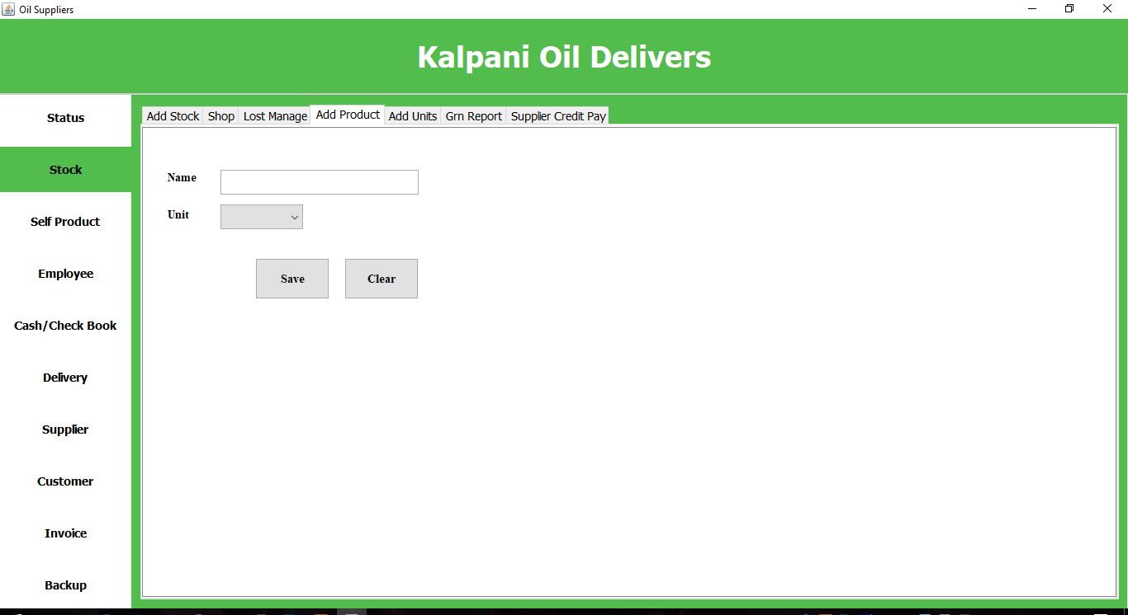

**Add Units**

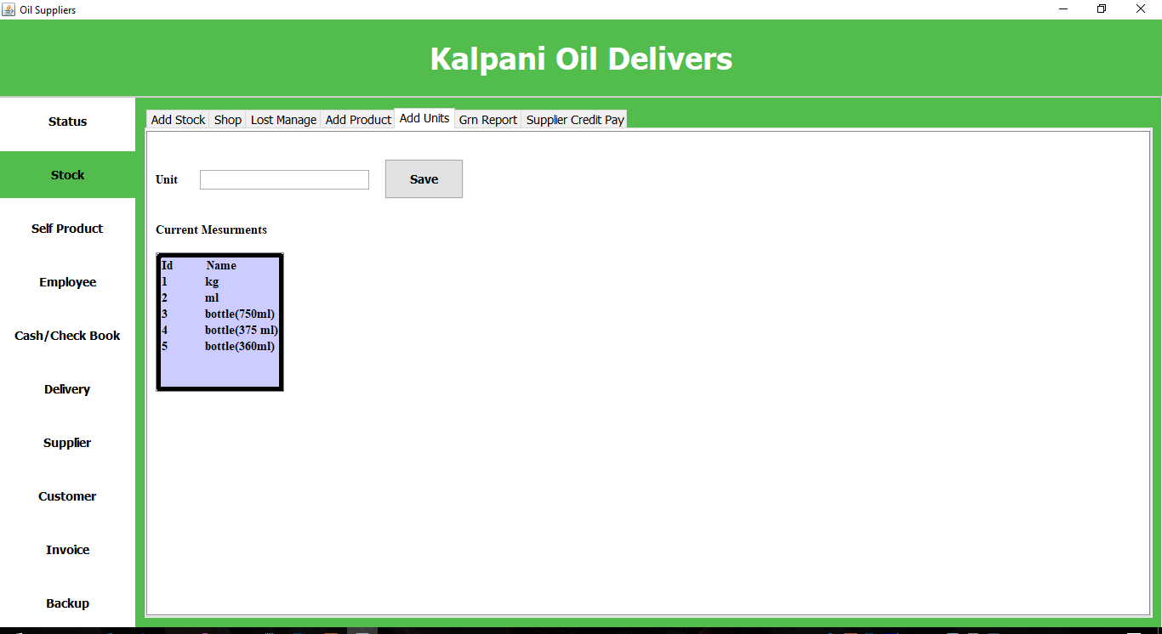

**GRN Report**

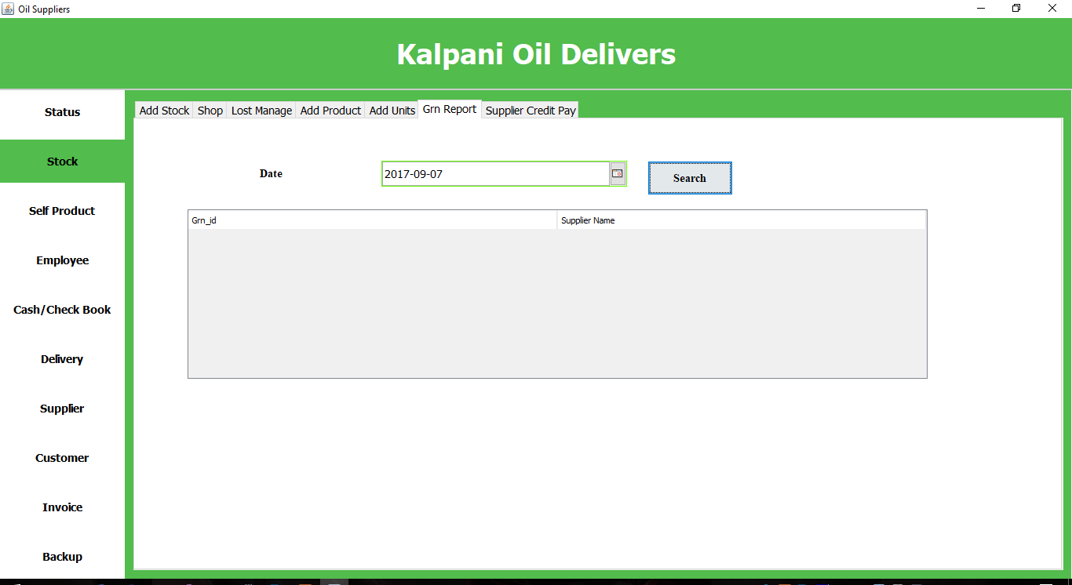

**Supplier Credit Pay**

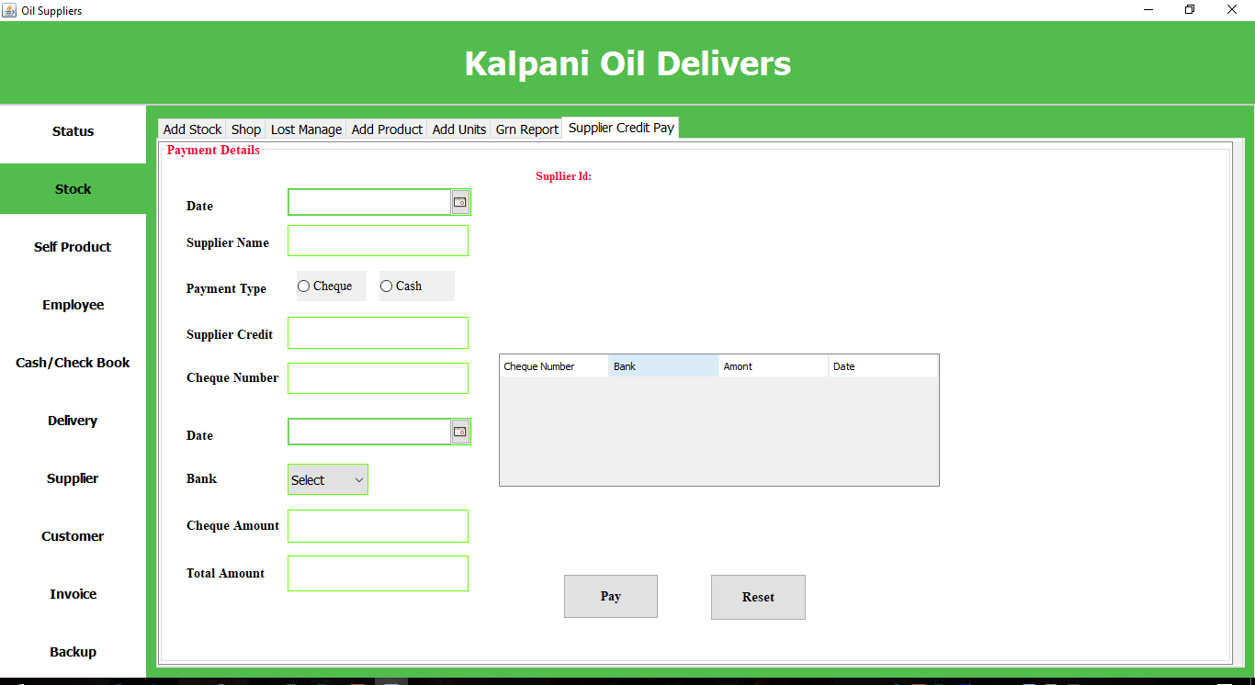

**Self-Product**

**Add Product Mix**

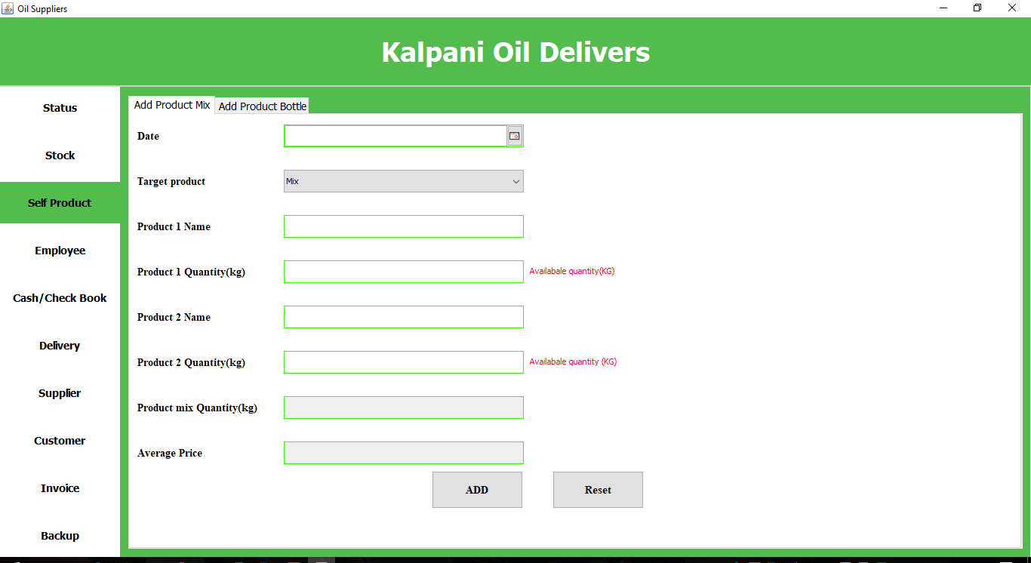

**Add Product Bottle**

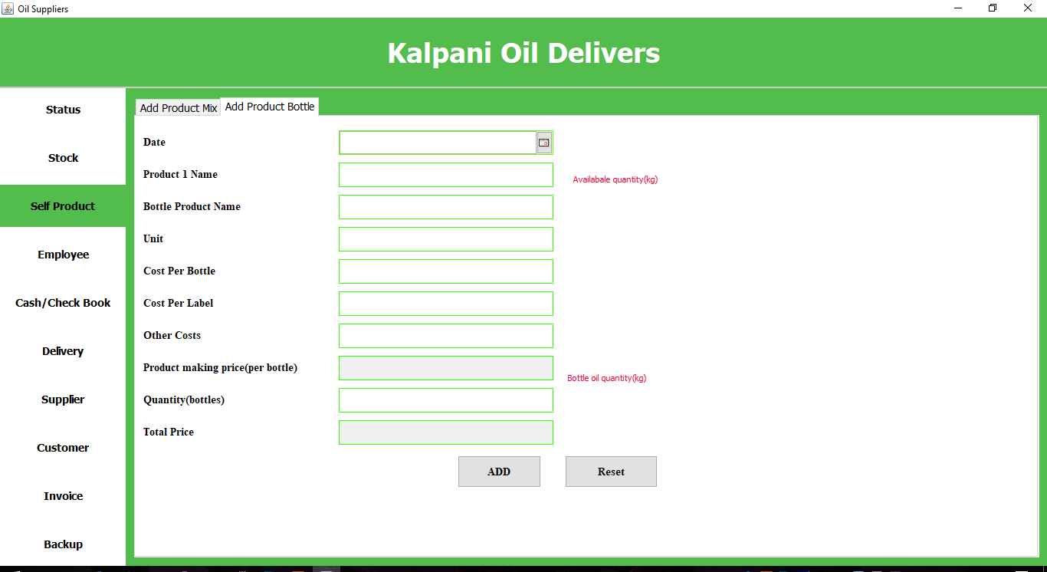

**Employee**

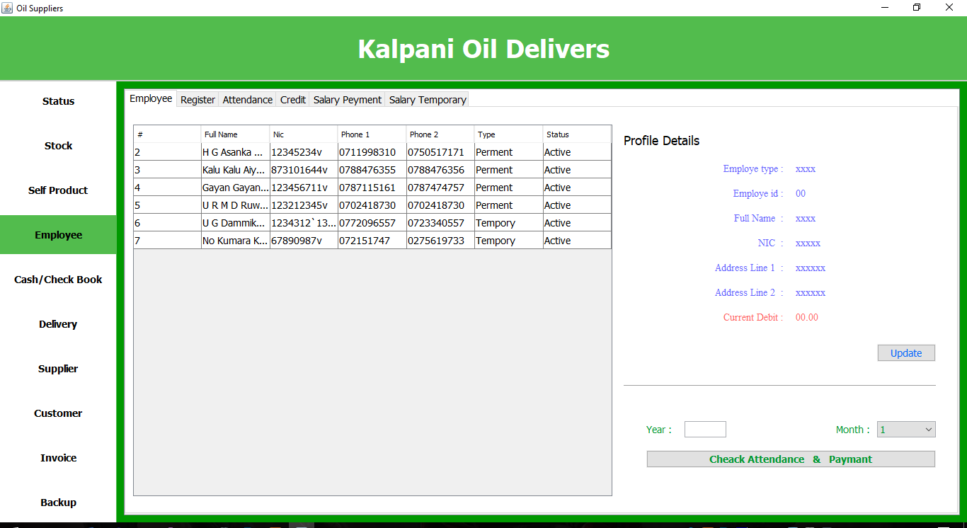

**Register**

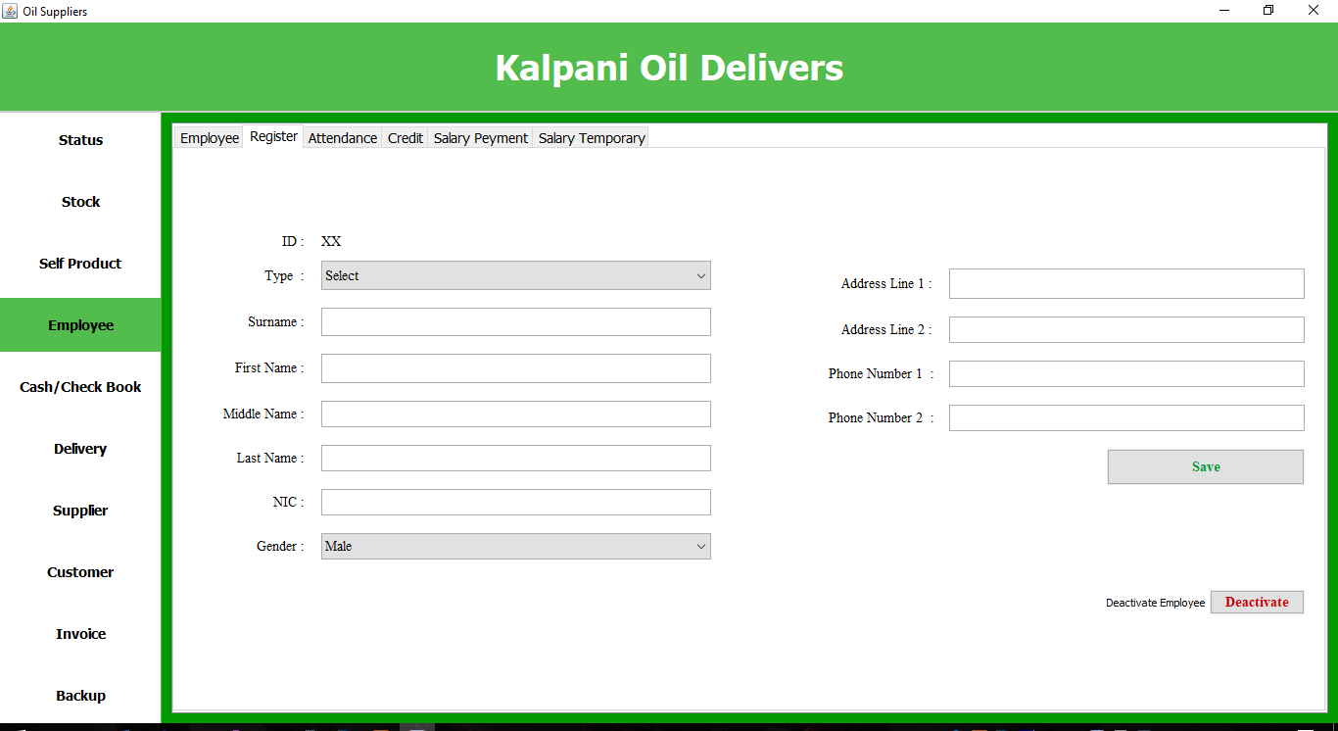

**Attendance**

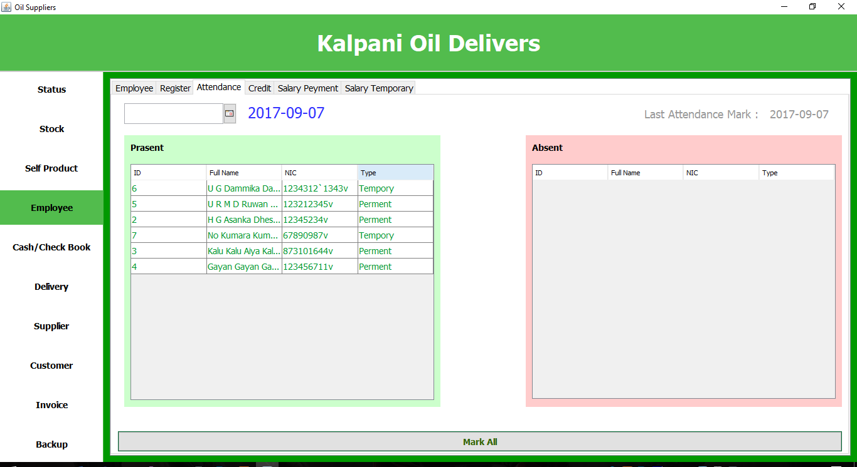

**Credit**

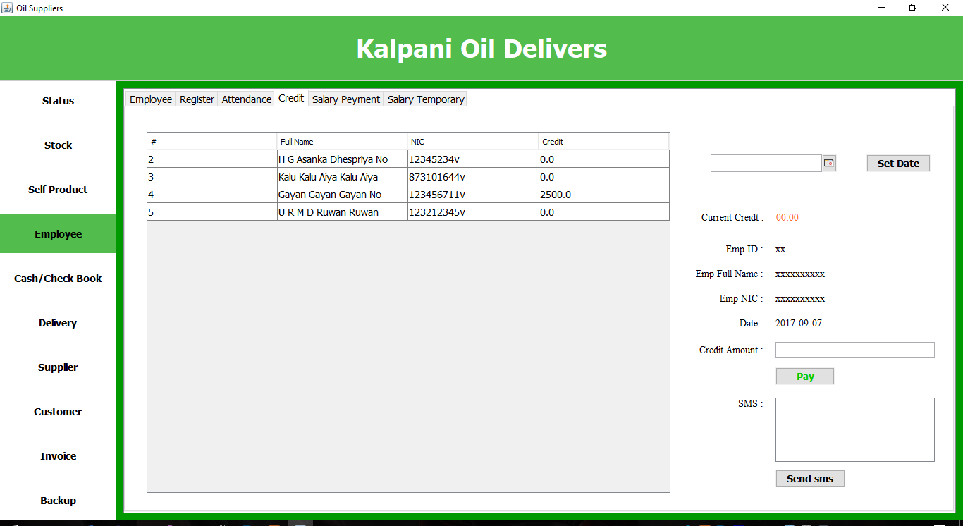

**Salary Payment**

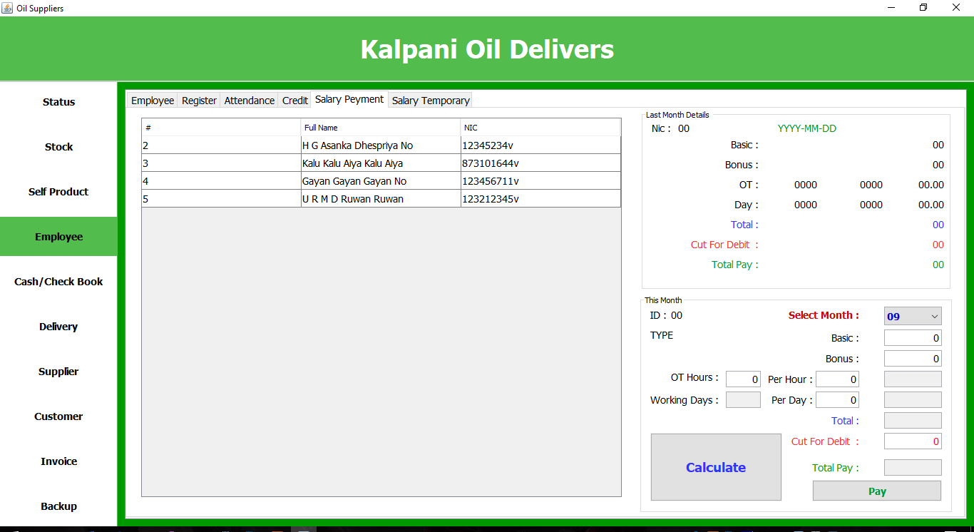

**Salary Temporary**

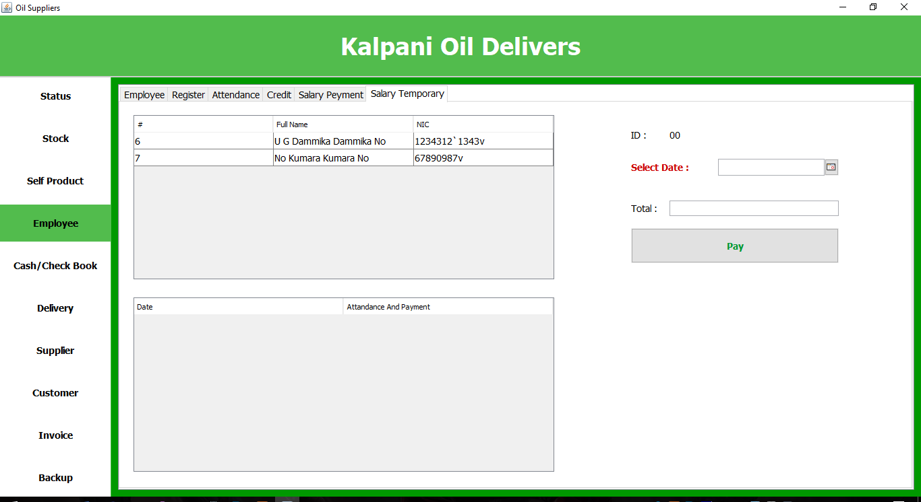

**Cash /Check Book**

**Summary**

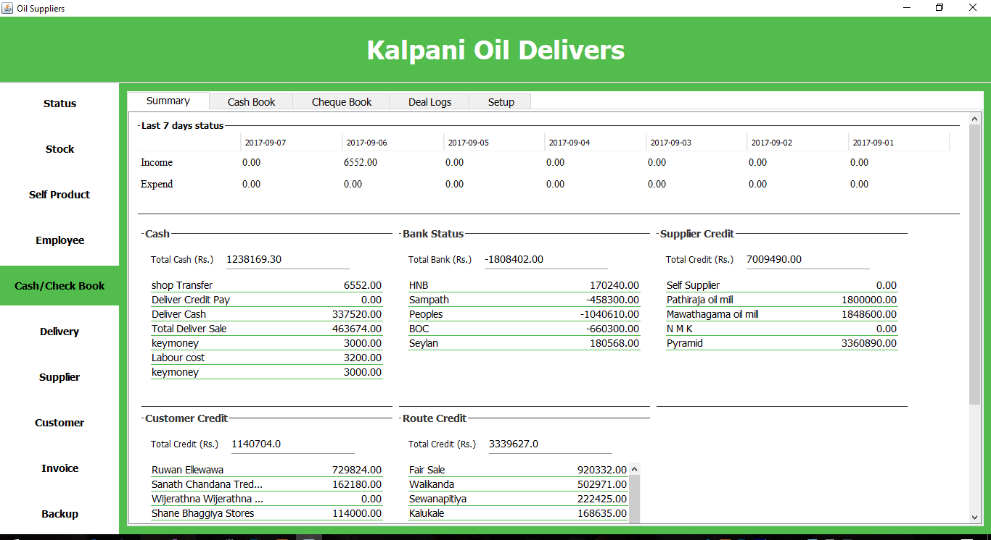

**Cash Book**

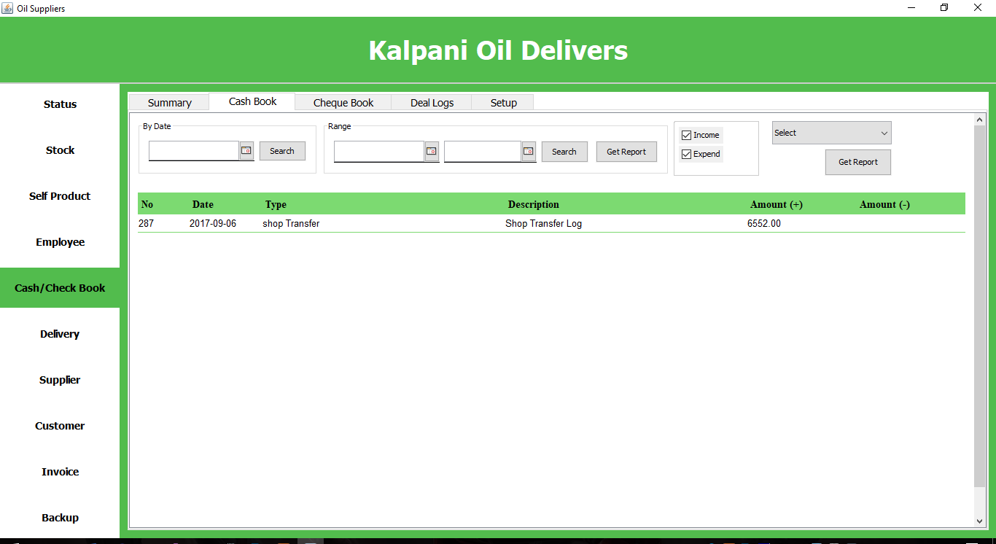

**Check Book**

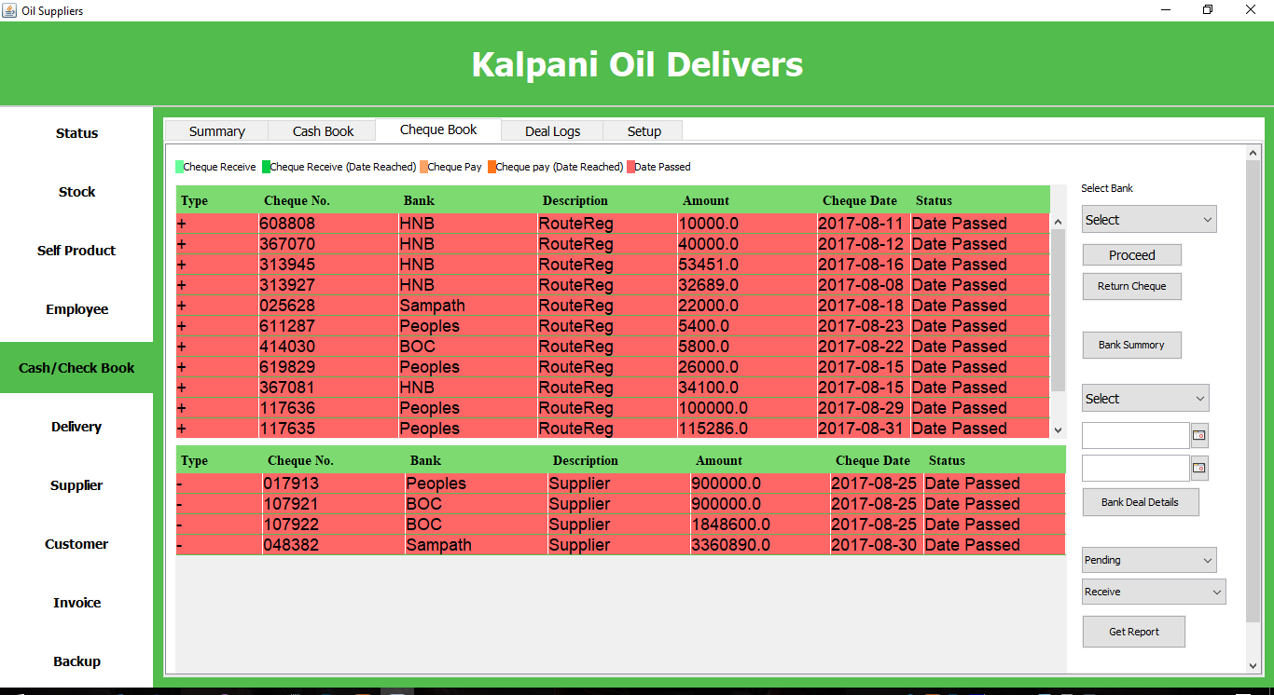

**Deal Logs**

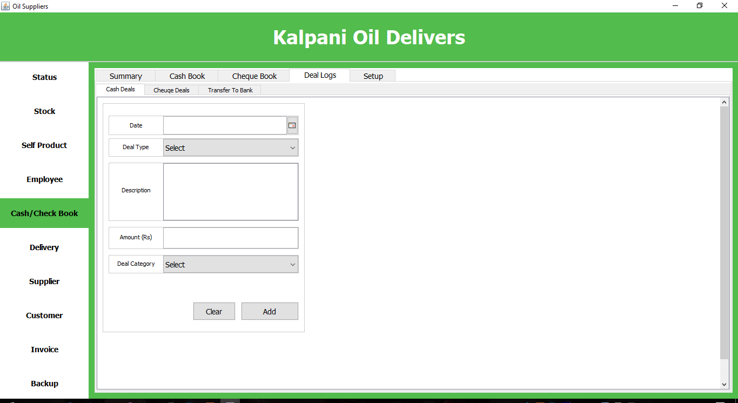

**Setup**

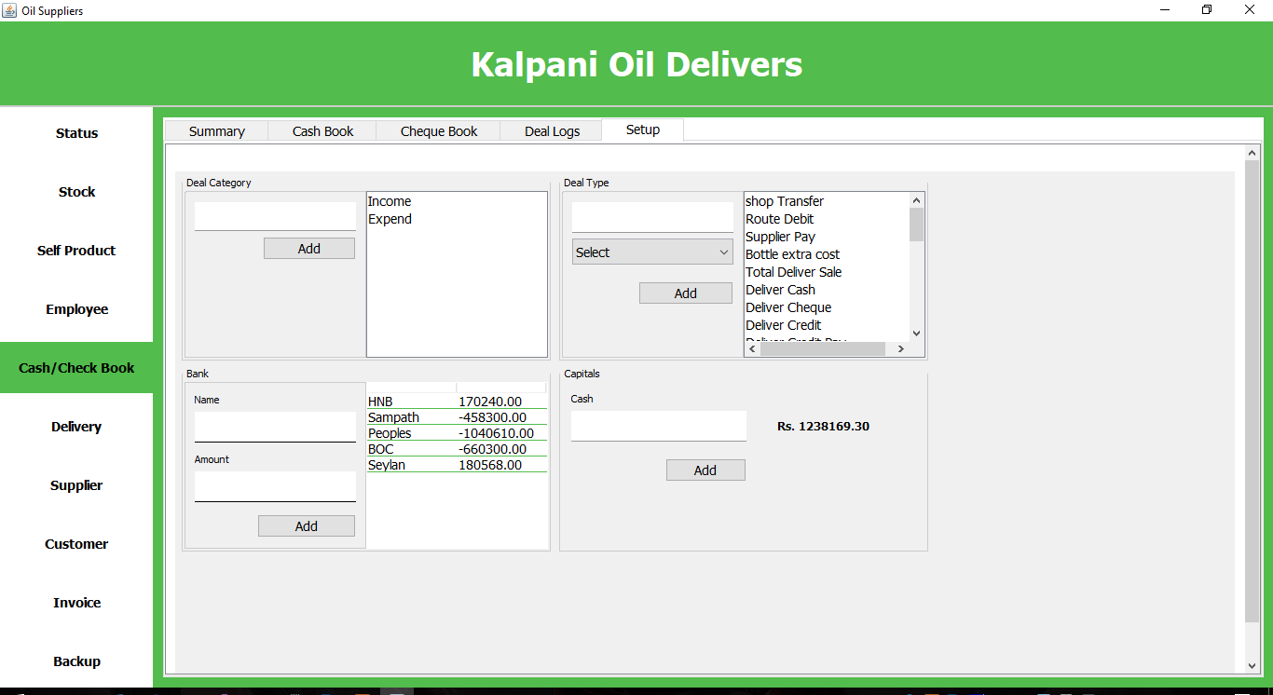

**Delivery**

**Delivery Vehicle**

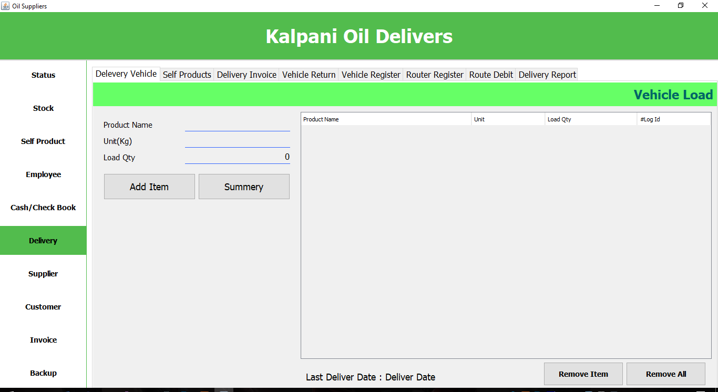

**Self-Product**

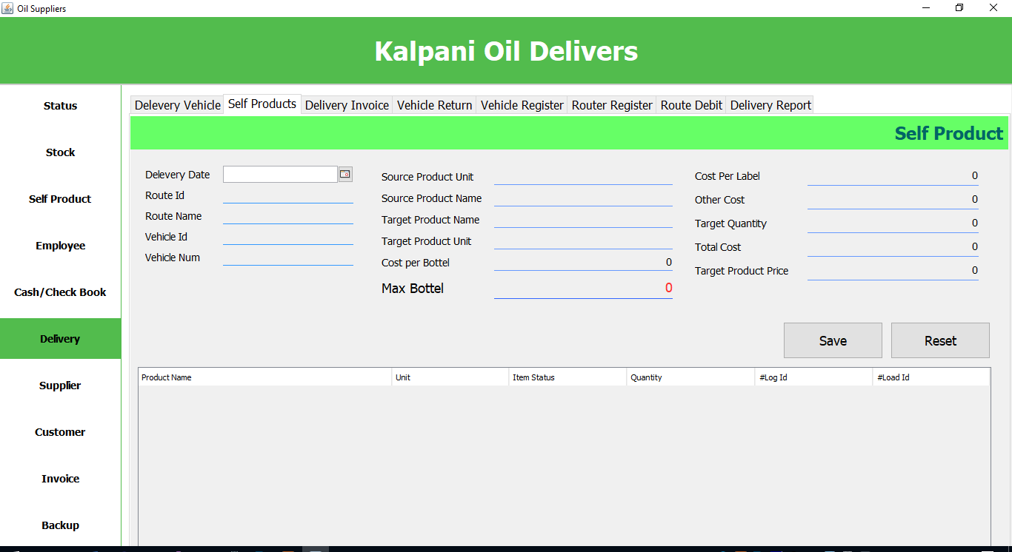

**Delivery Invoice**

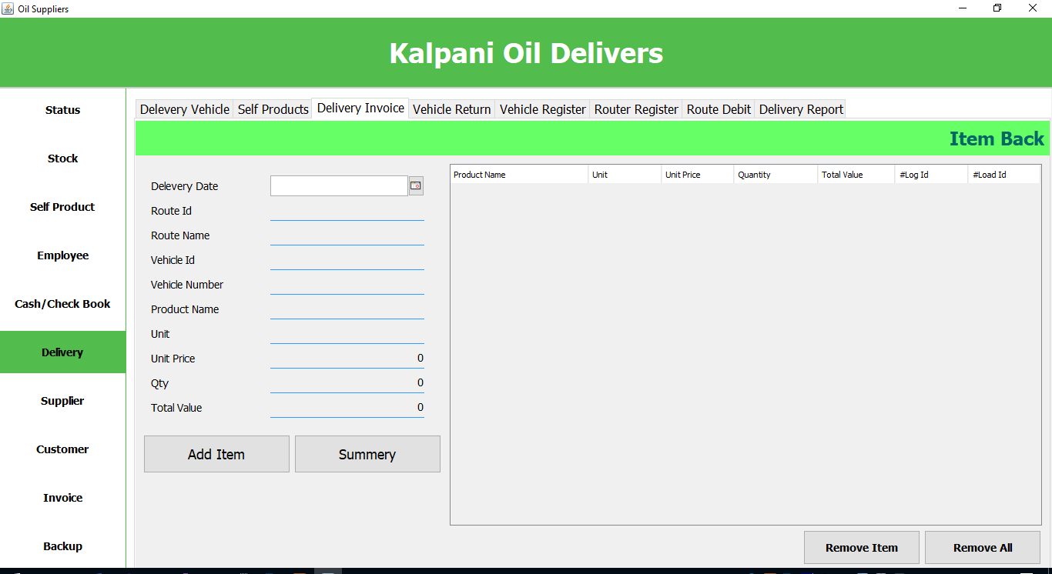

**Vehicle Return**

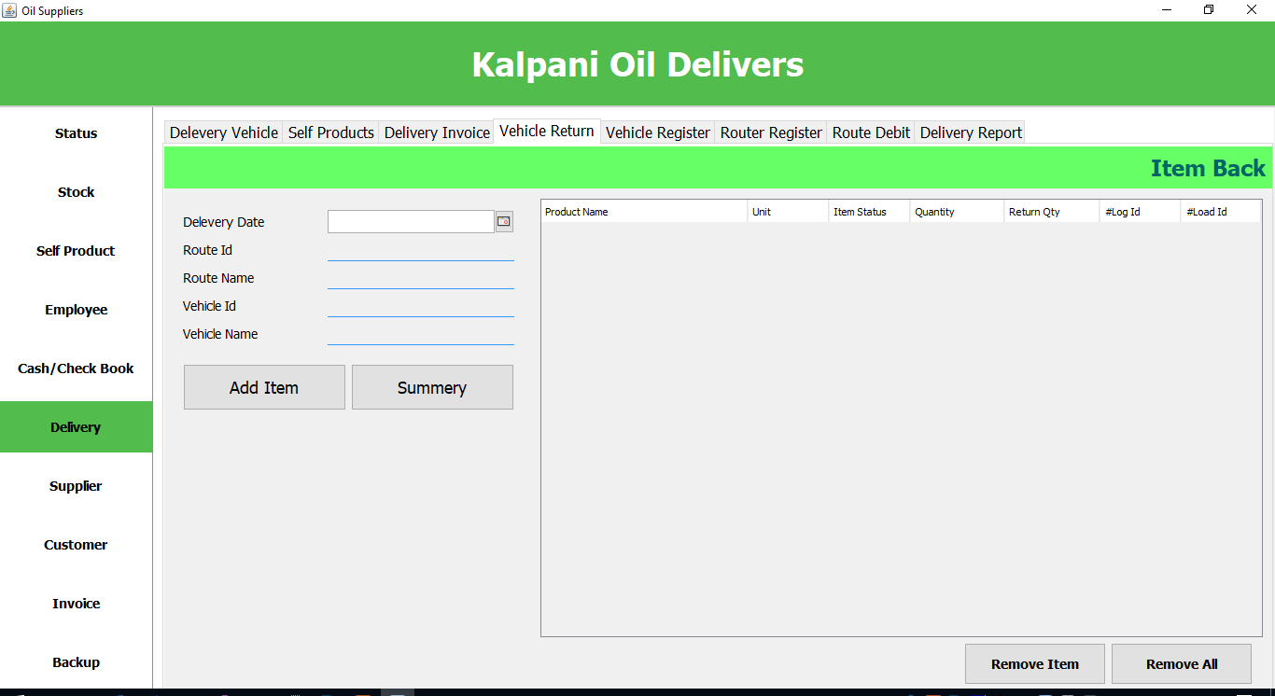

**Vehicle Register**

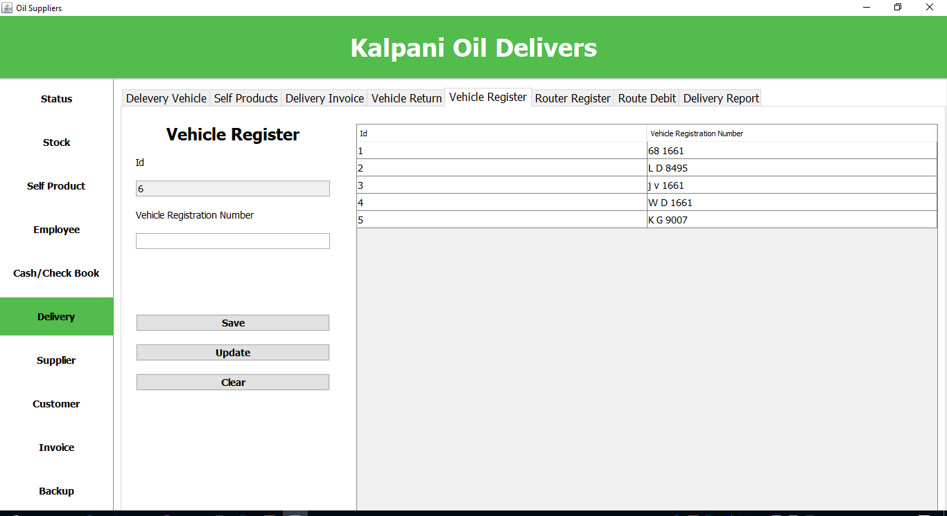

**Route Register**

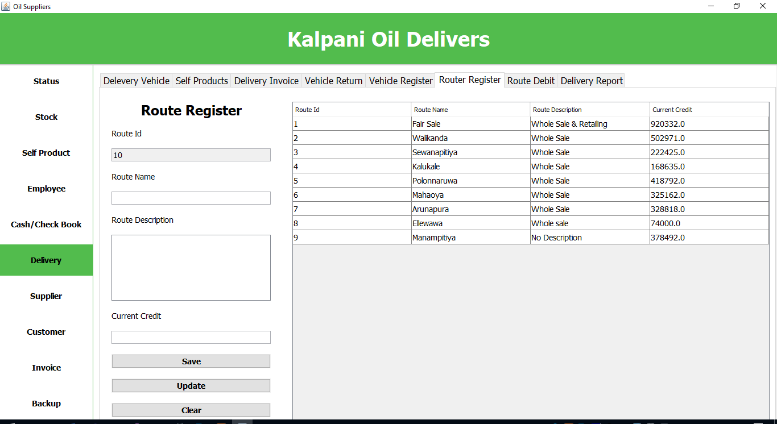

**Route Debit**

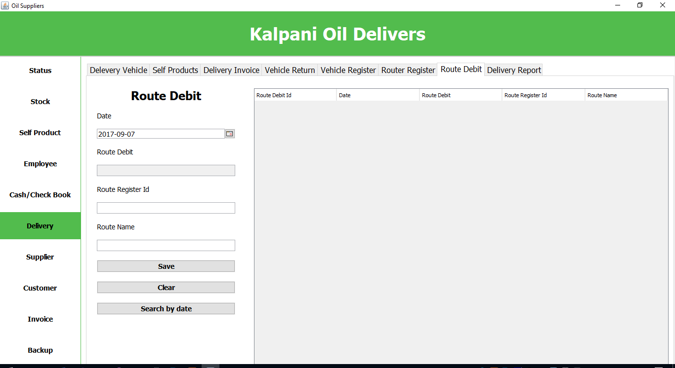

**Delivery Report**

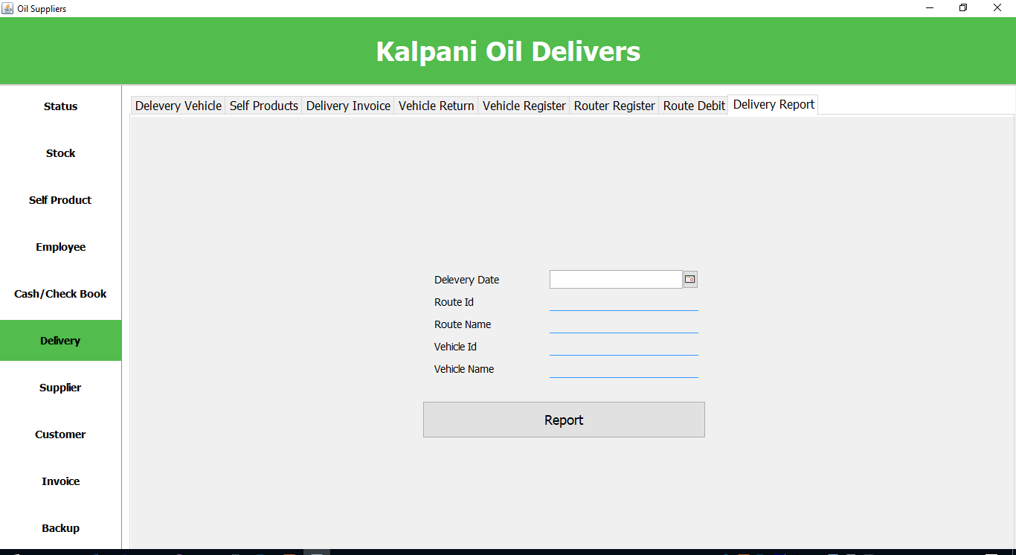

**Supplier**

**Supplier Register**

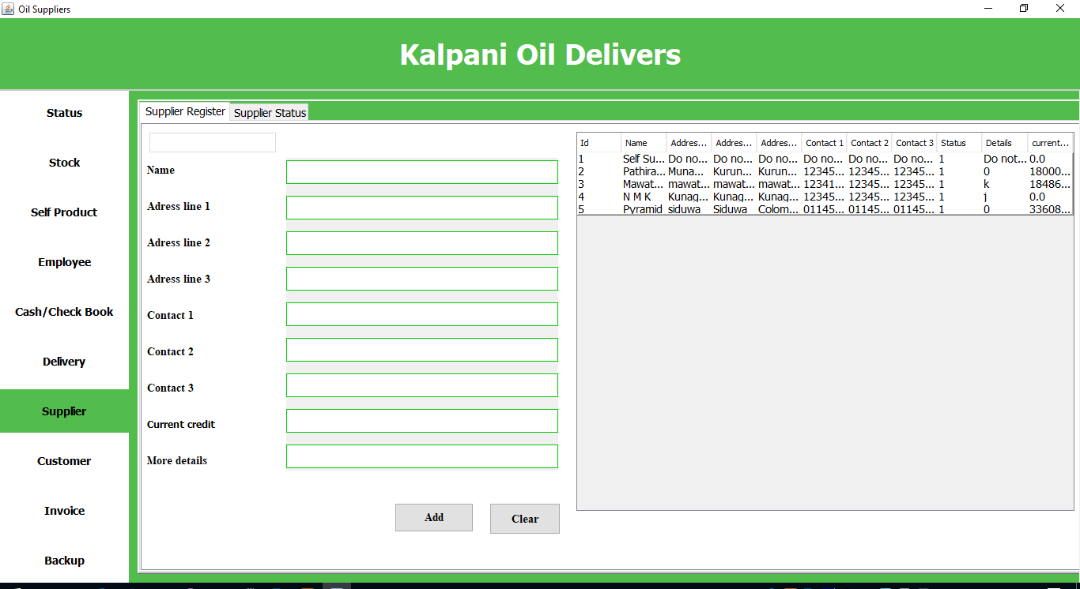

**Supplier Status**

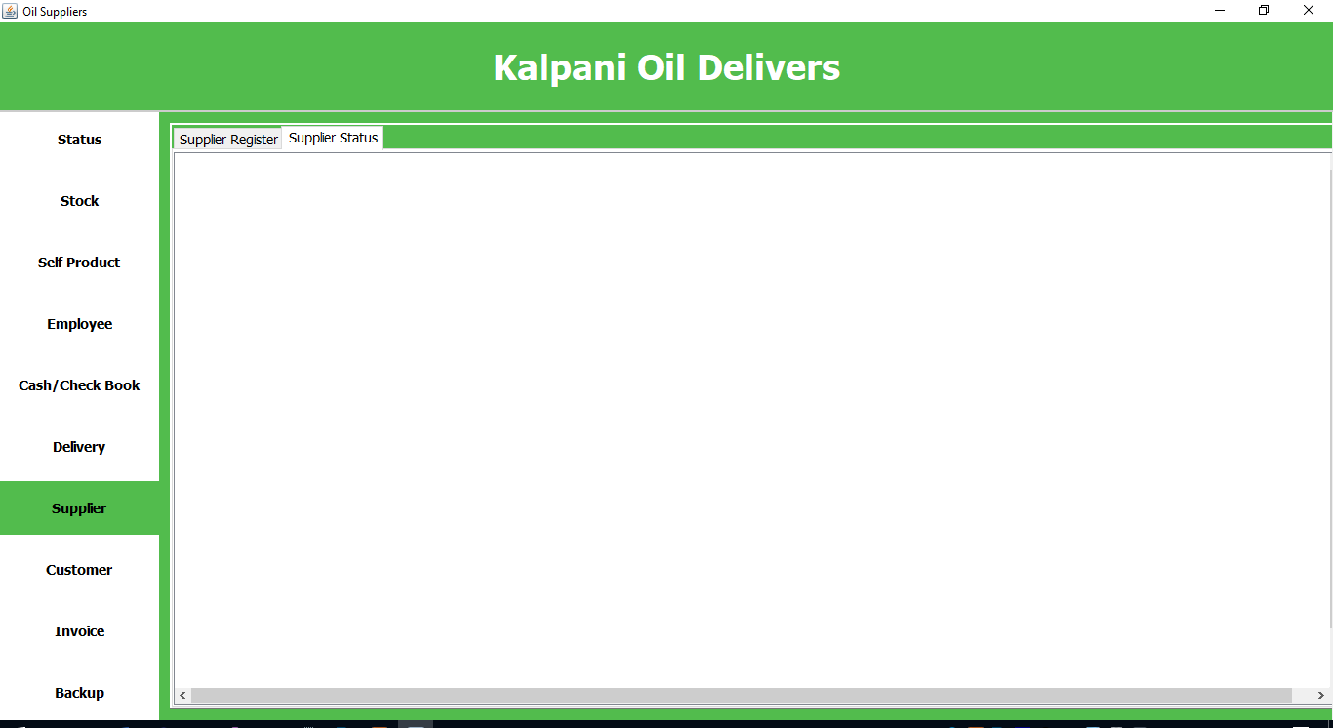

**Customer**

**Register Form**

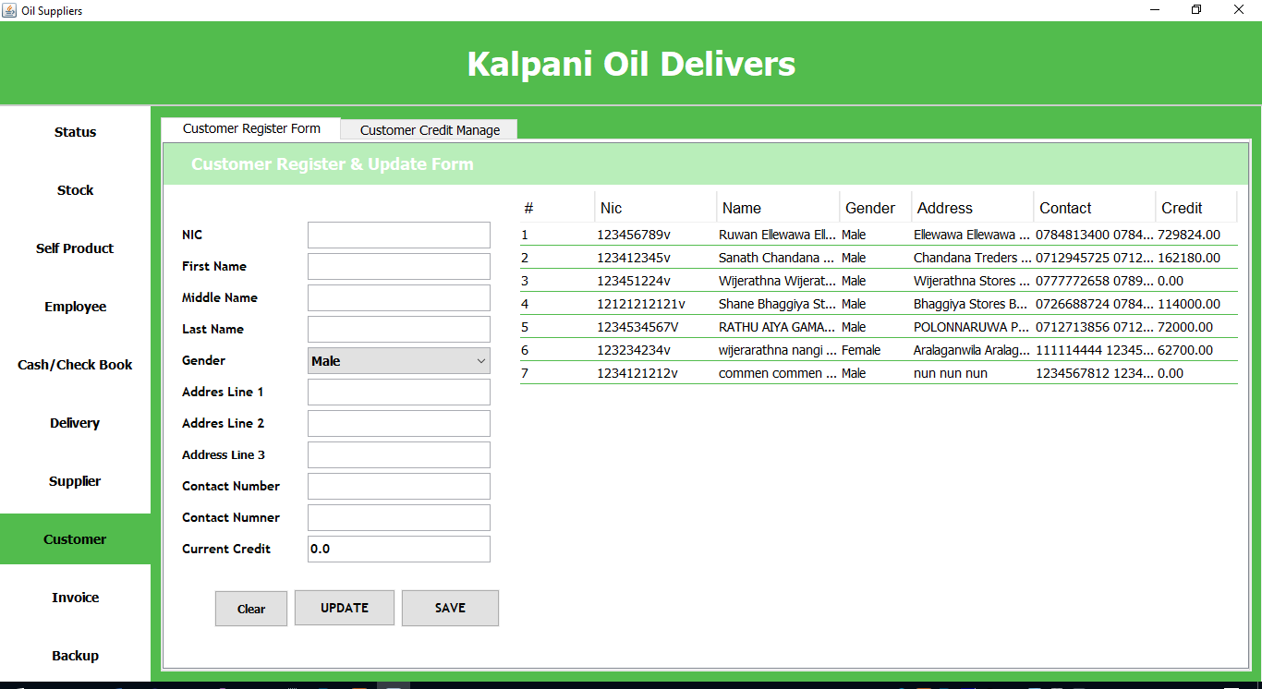

**Credit Management**

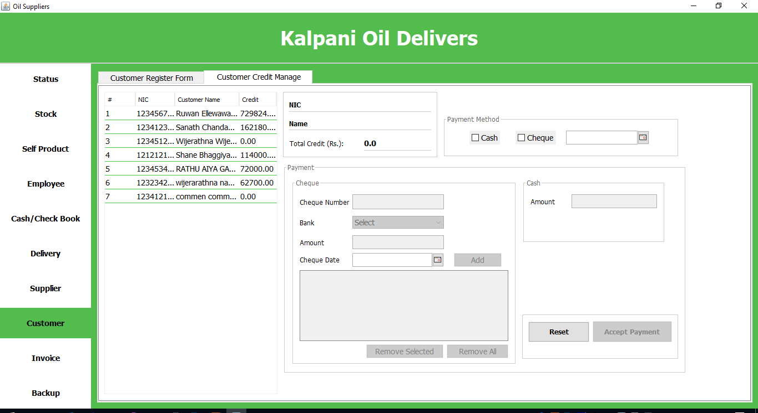

**Invoice**

